*Micro-Structural optimization for combined   
thermal and mechanical load-bearing materials*  
  
M.sc Thesis

Idan Distelfeld

Advisor:Prof. Shmuel Osovski

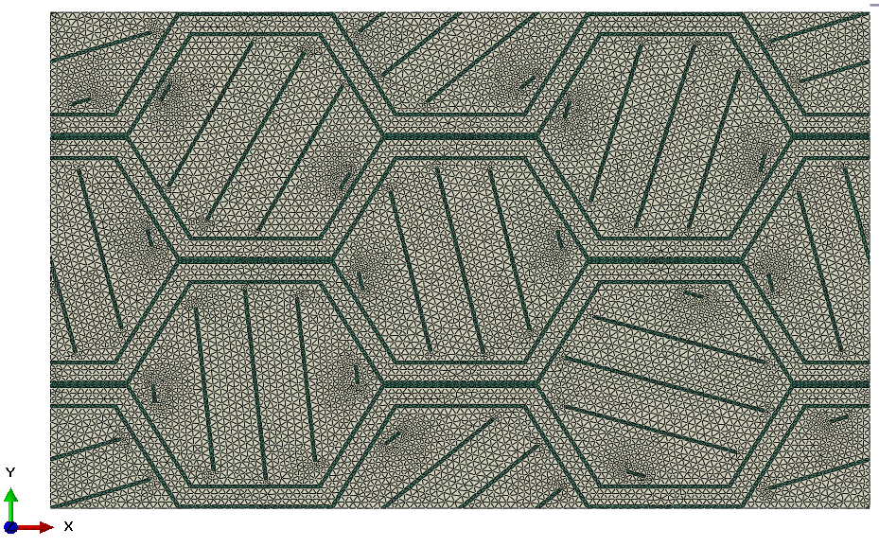

Table of Contents

Abstract: 3

Introduction: 4

Objectives: 6

Background: 6

Composite materials: 6

RVE Homogenization : 7

Thermal and mechanical bounds for effective properties: 9

Rule of Mixtures bounds : 9

Hashin Shtrikman bounds : 9

Surrogate modeling**:** 11

Artificial Neural Nets (supervised learning ): 11

Gaussian process regression: 14

Surrogate based Optimization: 16

Design Of Experiments(DOE): 17

Optimization algorithms : 18

GA method: 19

Multi Objective optimization (NSGA II): 20

Method: 22

The optimization problem: 22

RVE Geometry and design variables : 22

Parametric model generation : 23

Element size and type definition: 26

Mesh Convergence: 27

Material selection : 28

Equivalent Elastic properties calculation: 33

Equivalent Thermal properties calculation: 35

Surrugate based optimization : 36

Surrogate models calibration and comparison: 37

Exploring the design space : 43

*Reinforced with dual angles**( 2 parameters)* 47

Optimization: 56

Goal based optimization: 56

Multi objective optimization using NSGA II 62

Discussion: 71

Summery: 71

8.References: 72

# Abstract:

This thesis demonstrates a surrogate model based Thermo-mechanical optimization method of a composite representative volume element (RVE).The RVE model is based on a metallic honeycomb structure filled with polymeric lightweight resin and reinforced by inclined metallic fibers. A parametric model is generated and simulated using Finite element method (FEM) with Thermal and mechanical loading , periodic boundary conditions and homogenization theory .  
The 10 dimensional parametric design space is spanned by Latin Hyper-cube sampling algorithm using 5000 samples which are simulated using FEM simulation to calculate the effective Elastic and thermal conductivity properties .The generated dataset is used to train a low cost surrogate Neural Network(NN) model which is used for the multi-objective optimization proccess using NSGA II algorithm. The method presented shows a fast , accurate and flexible optimization method which allows altering the RVE Elastic ,Thermal and Density properties for the specific design task.

# Introduction:

The need for higher payload ratio vehicles as well as the increased cost of launch vehicle load reaching up to 50,000 USD/Kg [1] , are driving the aerospace industry’s pursuit for light-weight structures. Light-weighting is achieved mainly through two intertwined engineering thrusts: adoption of new materials and smarter designs [2]. In many aspects, the field of composite materials can be viewed as the ultimate engineering discipline for lightweight structures, as it benefits from the progress in both materials research and data-driven design methodologies.

A major design effort related to aerospace vehicles, revolves around the necessity of providing a thermally insulating structure with load bearing functionality. As an example to aircraft sub-systems in which such needs arise, one may consider the concept of Integrated Thermal Protection Systems (ITPS) [3]–[5] . The main idea is to integrate both the thermal and load bearing structure ,instead of providing distinct solutions, thus saving both weight and volume while satisfying both of the requirements. ITPS are usually constructed from three structural elements, two of which are made of sheets (top and bottom facing) and a lightweight core structure sandwiched in between. Such systems result in a conflicting demand from the core structure. On one hand, the core structure is designed as to assist the skin elements in maintaining their shape by providing mechanical support, while on the other hand, it is expected that the core structure will be designed as to minimize the amount of heat transfer between the top and bottom facing sheets. Finally, as mentioned earlier, maintaining the light-weight constraint is of great importance.

Another field that is concerned with Thermo-Mechanical load bearing structures is the field of structural engineering related to the design of building blocks [6], [7] .Building blocks structure has to be stiff and strong to bear the building structural weight and to resist damage in case of natural disaster. In addition, thermal insulation is required to reduce energy consumption and greenhouse gases emissions. Finally, Maintaining low material volume fraction is needed for cost reduction.  
Designing a thermo-mechanical load bearing structures is not a trivial task: While the strength and stiffness requirement leads to higher volume fraction of the stiff phase , the thermal insulation and light-weighting requirements leads to higher volume fraction for the isolation/void phase. Therefore, in order to fit the structure to the specified thermo-mechanical multi objective design criteria and obtain an ideal structure, an optimization process has to be taken.

|  |  |
| --- | --- |
| Figure 1.Masonry blocks under thermal and mechanical loading . a) typocial staggered design .b) topology optimized design .Figure taken from [7] | Figure 2.Typical currugated core ITPS structure under thermal and mechanical loading. The structure consists of load bearing sandwich structure filled with isolating phase to minimize heat trasmittance .Figure taken from [8] |

Extensive work has been done optimizing material Elastic[9] ,Thermal[10] and thermo-elastic[11], [12] properties using topology optimization and inverse homogenization method [13] on voxel based representative volume elements (RVE) .This work takes an engineering approach by optimizing a parameter based RVE design for the thermo-mechanical and light weighting requirements using both Finite elements method (FEM) ,homogenization based approach and periodic boundary conditions to calculate the effective thermal and mechanical properties. Finally. Surrogate models are used for the optimization process to enable full field presentation, quick convergence and better flexibility while selecting the different objectives.

# Objectives:

The objective of the current research are as follows:  
1. Utilize efficient Finite elements simulation for calculation of effective composite microstructure elastic and thermal properties using RVE and a homogenization-based approach.  
2. develop a method for optimizing composite microstructure for specific set thermal and mechanical goals.

# Background:

## Composite materials:

Composite materials are in vast use in the Aerospace, Automotive and Sports industries due to their high Strength and Stiffness while having a relatively low density. Using composites, allows the designer to align the major material properties in the loading direction and while minimizing the structural weight. Thus, expanding the physical boundaries previously known while designing using isotropic materials.

In composites, a soft and light matrix is reinforced with stiff metallic or ceramic particles to make a new, improved material with enhanced properties [14], [15]. Adding the reinforcement phase increase the material stiffness and strength while maintaining the ductility, damage resistance and thermal conductivity of the matrix. The properties of a composite material depend of the properties of the constituents, the microstructure, volume fraction and the interaction of the phases. Composites can be divided into 3 main groups , defined mainly by the matrix type : Polymer based(PMC) ,metal based (MMC) and ceramic based (CMC).   
The use of composites in high temperature environments , are generally dominated by the MMC and CMC types, reaching maximum temperature range of 1800 [C] [16] but in the cost of relatively high density and elevated manufacturing costs .

While PMC type composites provides the highest strength and stiffness to weight ratio as well as reduced thermal conductivity , its maximum operating temperature is limited by the polymer matrix relatively low glass transition point (Tg), reducing its load bearing capabilities as the temperature approaches this physical value. Advances in material science allows expanding the temperature range of PMC’s to the mid range of 150-300 [C] [17]–[20], allowing a large weight savings for structural elements .

|  |
| --- |
| Figure 3.A schematic comparison of material properties : Steel, Aluminum and Composites . Figure taken from [21] |

## RVE Homogenization :

The RVE term was first defined by Hill [22] and it can be described as the smallest volume element that can be representative of the material response at the macro scale .   
Generally , an RVE is used as a reduced model for the computation of effective material properties ,in order accelerate and simplify the calculation. The extracted properties are then used to form an equivalent material which will be used on a large scale simulation, reducing the complexity of the bigger problem while maintaining the micro scale information .

Using RVE’s homogenization methods, requires the imposing of uniform strain or thermal flux field over the RVE as well as periodic boundary conditions (PBC) [23] to represent an infinite continuous space filled with RVE’s of the same type responding to the loading conditions the same way.

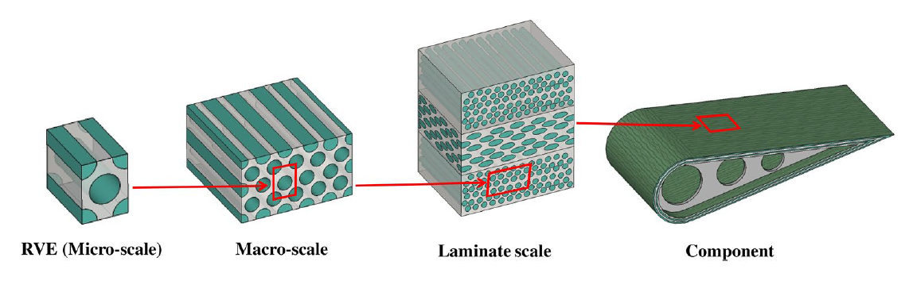

Figure 4.A unidirectional RVE in different length scales – from the unit cell to the lamina, laminate and component level. The RVE properties are used in the component level simulation reducing the total numerical cost maintaining the micro scale information . Figure taken from [24] .

Some of the common methods used for general homogenization of a RVE include mean field based homogenization [25] and asymptotic homogenization [26].

Mean field method are using FEM simulation to calculate the mean field response of a given RVE model for a prescribed loading conditions . The FEM solver is using the discretized representation of the unit cell model to apply and solve the basic constitutive equations on the individual model nodes in order to obtain the complex full field response solution for the model .Then, the effective properties are calculated averaging the models response over the model volume / surfaces and substituting in the basic constitutive relations.

## Thermal and mechanical bounds for effective properties:

Rule of Mixtures bounds :  
The simplest bounds derived by Voigt and Ruess (Ref Ref) also refered as Rule of mixtures bounds . These bounds are computed using simple Axial(Parallel) and (Transverse) Serial loading to compute the upper and lower bounds respectively .The model is based on lamelar structure where the plates edges are aligned in the axial (Voigt) direction and faces facing the transverse direction. The bounds can be described as follows :

(1) $E_{Voigt}=v_{1}E_{1}+v_{2}E_{2}$

(2) $E_{Ruess}=\frac{1}{(\frac{v_{1}}{E_{1}}+\frac{v_{2}}{E_{2}})}$

Where $E_{1},E_{2},v_{1},v_{2}$ are the elastic moduli and volume fraction of the phases .

### Hashin Shtrikman bounds :

Hashin and Shtrikman derived both upper and lower bounds for both shear and bulk moduly [27]. The model assumes that the material is quasi-isotropic and quasi homogenic and the microstructure can be described by spherical inclusions of one phase embedded in the other phase. These bounds are known for their relatively tight range for both the Bulk and shear moduli. The bounds can be decribed as follows :

(3) $K^{*}=K_{1}+\frac{v_{2}}{\frac{1}{K_{2}-K_{1}}-\frac{3v_{1}}{3K_{1}+4G_{1}}}$

(4) $G^{*}=G_{1}+\frac{v_{2}}{\frac{1}{G_{2}-G_{1}}+\frac{6\left(K_{1}+2G_{1}\right)v_{1}}{5G_{1}\left(3K_{1}+4G_{1}\right)}}$

Where $K,G,v$ are the bulk moduli, Shear moduli and volume fraction respectively . The higher bounds obtained when $K_{2}>K_{1},G_{2}>G_{1}$, the lower bounds is computed by exchanging the indices .   
Equivalent thermal conductivity bounds was derived by Maxwell and Eucken .Ref . Those bounds are Mathematicly identical to Hashin and shtrikman bounds . Many other bounds has been proposed by Milton and kohn [28], Wills [29] etc.

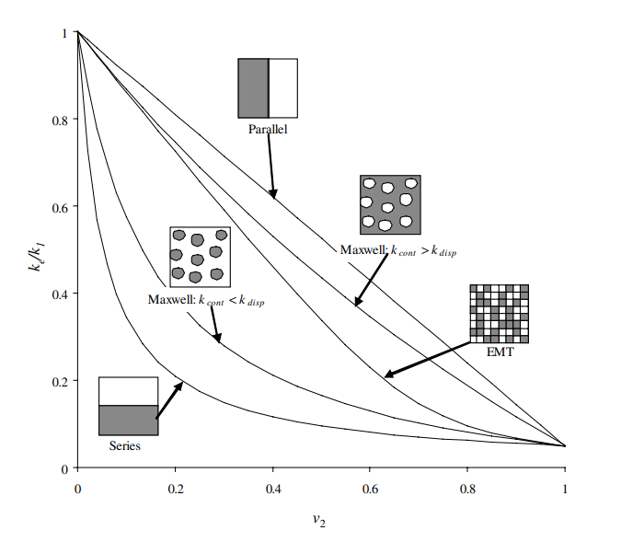

Figure 5.comparison of Voight and Ruess (Rule of mixtures) and Hashin-Shrikman/Maxwell Eucken bounds regarding thermal conductivity as function of the volume fraction. Figure taken from [30]

## Surrogate modeling**:**

Artificial Neural Nets (supervised learning ):  
Artificial Neural Nets(ANN) [31] are mathematical inventions inspired by observations made in neuroscience. An ANN can be described as mapping an input space to a desired output space. It gained increased popularity in recent years due to its simplicity, robustness and high efficiency dealing with large databases. In [32], [33] ANN was used to predict the microstructure -mechanical properties linkage of composites and foam-like structures. Furthermore, ANN are also used to identify the phase distribution and geometry of a multi phase material from its section image and derive its effective properties by this information [34]–[36] . The concept of ANN training is built on optimizing its prediction capabilities with respect to the net multiple parameters (i.e weights , biases ) until the best result is obtained. ANN architecture consists of input layer , hidden layers and an output layer which acts as the function variables, actual function and function output respectively .Each of the layers consists of a basic entity- the neuron . Each of the neurons has multiple connections to the previous and next layer neurons . Using those connections , the input data is transferred from the input layer to the hidden layers and the output layer to make the final prediction.  
A single neuron is defined by his set of weights , bias and a transfer function (scematic representation of the net architecture can be seen in Figure 5). The weights are a measure of strength of the connection between one neuron to another , the higher the weight, the bigger the influence of the relation between the neurons. Bias is a scalar that acts as a threshold value for the neuron activation . The transfer function is a nonlinear function that maps the neuron weighted sum with the threshold value to the neuron output . This function enables the model to account for non linearities in the input -output mapping .Using the weights , biases and transfer function- enables the definition of infinite number of distinct mapping functions. A single neuron calculation mechanism process can be defined mathematically by Eq 5 .Due to the simplicity of the equations and reuse of previously calculated data, it is scalable linearly with the amount of datapoints and parallelizable . Making it extreme valuable for large data sets trend mapping.

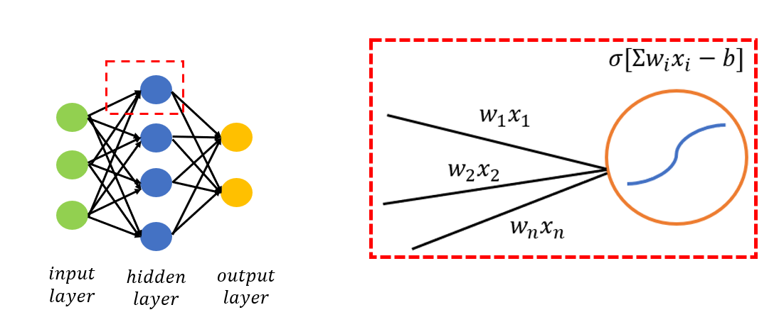

Figure 6. Schematic representation of neural network architecture and a close up to a single neuron calculation mechanism. $w_{i}$ is the connections weight, x is the input value from the previous layer , $σ$ is the neurons transfer function and b is the neuron bias value .During the training phase the parameters are optimized with respect to the cost function.



(5)

(6) 

(7)   
  
In order to train the network to predict the input-output relation a cost function need to be defined. This function will grade the network performance when mapping the inputs to the outputs . One useful method in network regression is defining a Mean Square Error (MSE) cost function which simply subtracts the prediction values from the real output values ,squaring and averaging over the number of examples checked in the session or batch (Eq 6). Using this method, is forcing the network to address the most erroneous datapoints with greater weight.  
The goal while training the network is to minimize the cost function, as 0 value of the cost function is perfect prediction while higher values implies erroneous prediction.  
The minimization of the cost function is made by using back propagation algorithm. This algorithm is first passing the training values data through the untrained network in order to asses the cost function. In gradient decenet algorithm , the derivative of the cost function with respect to the individual weights and the chain rule ( Eq 7). Then,the weights of the network are changed in proportion the negative of the gradient. This process is repeated multiple times (epochs) until final convergence.

Typically ,the database is partitioned into 3 parts:Training ,Validation and Test data. The training part is used for changing the weights a biases through the gradient decent and back propagation algorithm, the validation dataset is used during the training phase in order to asses the performance of the model on untrained dataset in order to prevent overfitting. The test dataset is used to examine the trained network on a data that it never seen before , differentiating it from the validation test. In the following work, the network was trained based on the validation accuracy and its final accuracy was measured based on the testing accuracy.



Figure 7. Nueral net training process . The net was training accuracy was defined by the validation accuracy to prevenet overfitting. It can be see that from epoch 200 the training accuracy is improving although the validation and testing accuracy worsens. The final net parameters are selected according to the best validation accuracy obtained .

### Gaussian process regression:

Gaussian process regression (GPR) [37] is another technique for surrogate mapping of an input data to some output . The model is a probalistic model based on a gaussian distribution of each of the models variables and outputs .GPR is widely used in mechanical and material science-[38] Used GPR to predict the microstructure -properties mapping for different unit cell structure configurations as a part of optimization process.   
[39] made use the method to predict the micro springs performance based on computationally expensive FEM simulations , resulting in a numerically low cost continuous mapping of the design space . The base idea of GPR that infinite number of functions can be fitted though our data set using different mapping functions .As described in equations 8-11 The model is using a statistical approach to calculate the mean function value out of the probable function set as well as the standard deviation at each point in the design space . Using selected kernel function (Eq 12) k(x) and the existing dataset- a covariance matrix is calculated. The matrix is used to generate the mean $μ(x)$ and covariance $W(x)$ functions .One of the benefits of GPR is the ability to use prior knowledge regarding the nature of the regression function to obtain better prediction accuracy- by setting a proper kernel function on the definition phase. In addition, This method is having the advantage of knowledge regarding the amount of uncertainty in each point in the design space . The main drawback regarding this method is that it is computationally expensive as it scales with O($n^{3}$) due to inversion of the covariance matrix in the model calculation process, eliminating its use in large data sets .

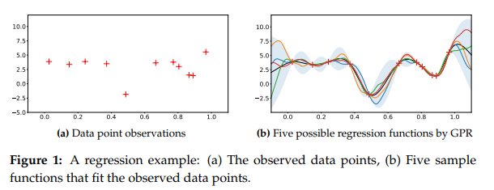

Figure 8. Sample data and Gaussian process regression result . the sample data can be fitted using infinite number of functions . The model result is the mean function (black graph) and the standard deviation (marked in grey) . As the model get further from the known data points the probability for error increases , resulting in a larger std value .figure taken from [40]



(8) 

(9) 

(10) 

(11) 

(12) 

Where $x_{i}$ is the input values , $y(x_{i})$ are the output values , $f$ represents the collection of the functions that fits the data. $k$ is the kernel function , $μ$ is the mean function , $w$ is the the standard deviation function , and $K$ is the covariance matrix . x are the known points while $x^{*}$ are the unknown points.

## Surrogate based Optimization:

As mentioned before, the objective of the research is optimizing the various geometry parameters so that the micro-structure will have selected elastic and thermal properties while reducing the weight to a minimum. This task can be achieved in various methods : Direct or surrogate based optimization .Direct optimization methods are usually involving exploration a small portion of the design space ,making the task of validating the quality of the optimized solution very difficult .In addition, using direct optimization generally require a large number of design cases which are generated during the optimization process .This can be resulted in high computational time to get an optimization result for each objective set. In surrogate based optimization[41], a different approach is being used - smooth and continuous model -a surrogate is first generated using Design Of Experiments [42] (DOE) algorithms to span the design space and exact numerical calculations of the previously generated design points. Then, Instead of using the heavy exact model, the optimizer uses the light surrogate approximation for the optimization process , enabling fast convergence to the pareto front ,validation for global minimum and flexibility in objective function definition.

## Design Of Experiments(DOE):

DOE algorithms are statistical tools generated to span a known parameter space , generating design points that can be representative of the parameter space. Latin hypercube sampling [43](LHS) is a well known DOE  for generating a near-random samples of parameter values from a [multidimensional distribution](https://en.wikipedia.org/wiki/Multidimensional_distribution) in a space-efficient way. In the context of statistical sampling, a square grid containing sample positions is a latin square  if (and only if) there is only one sample in each row and each column. When sampling function of n {\displaystyle N}variables using m datapoints, the range of each variable is divided into{\displaystyle M} m equally probable intervals. Then, m{\displaystyle M} sample points are placed to satisfy the Latin hypercube requirements. In the following work, LHS will be used to generate multiple design points that spans our parameters space .

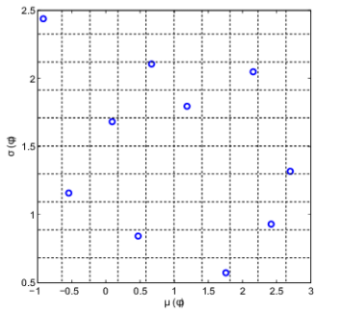

Figure 9. 2D Latin Hypercube DOE example with 10 design points .The design space is divided into 10 rows and columns ,each of them contains only a single design points .

## Optimization algorithms :

Optimization techniques[44], or algorithms, are used to find the solution to the problem specified in Eq. 1. The procedure consists of finding the combination of design variables values that results in the best objective function value, while satisfying all the equality, inequality and side constraints. Two of the well known optimization families are Gradient based algorithms and Evolutionary algorithms. Gradient Based algorithms makes use of the local gradient information in order to find an optimum solution. Those algorithms are widely used due to their superior computational speed and relative low number of steps for convergence. However, they also have several drawbacks which include that they can only locate a local optimum, they have difficulty solving discrete optimization problems and they may be susceptible to numerical noise. Evolutionary optimization algorithms [45] are population based algorithms inspired by nature . Unlike the gradient based techniques, where a single design point is updated from one iteration to the next, these algorithms do not require any gradient information and typically make use of a set of design points to find the optimum design. The population based exploring allows those algorithms to converge to a global minima at the cost of inferior computational time due to the multi point calculations . Using surrogate based optimization , enables rapid approximation of the design point, eliminating the computational time drawback.

### GA method:

GA method is an evolutionary algorithm inspired by Darwin’s principle of survival of the fittest. It is having the advantage of being extremely robust, having an increased chance of finding a global or near global optimum, being easy to implement and being well suited for discrete optimization problems .

The basic steps of a GA are illustrated in Figure 8 below. The first step is to create a random

initial population. The population is then ranked, based on the fitness (objective function) of each individual. The parent designs are selected in such a way that the higher ranked (fitter) individuals have a higher probability of being selected. The next generation is then filled

with children designs, created by randomly mixing the selected parent design properties (crossover) and imposing a randomized properties change ( mutation).

In order to keep the best solutions in the population and speed up convergence, the best solutions (elite) are passed onto the next generation without change(Elitism).  
The new generation is again ranked, and the process is repeated until convergence.

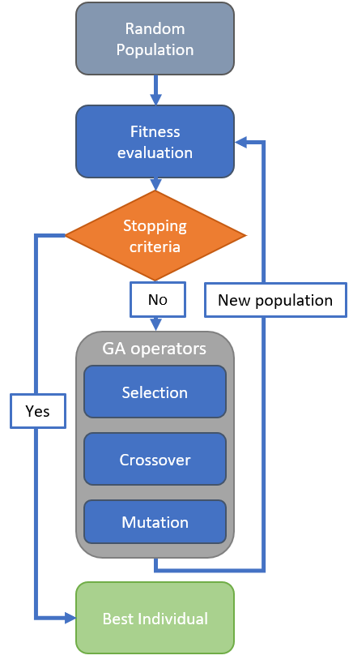

Figure 10.Ga flowchart

### Multi Objective optimization (NSGA II):

Multi objective optimization algorithms are concerned with optimizing a problem involving multiple objectives simultaneously. For most of the optimization problems , there is no one solution that optimize all objectives at once . Therefore , it is common to present the Pareto frontier which is a collection of the best solutions . On the pareto frontier , an improvement on one objective usually results in degrading in another one . One of the most famous multi objective optimization algorithm is evolutionary Non Dominating Sorting Algorithm II(NSGA II)[46]. The basic concept of evolution is similar to GA algorithm, although the fitness assessment process is different . The ranking method is based on dominance of the solution rather than analytical grading . After The initial population is generated it is sorted by frontiers based on dominance of the individuals with respect to each other . In the next step, A secondary sorting is made within the frontiers by the measure of crowding distance. Crowding distance is the measure of the distance to the nearest neighbors in the same frontier . Using this method reduces the risk of over crowded or vacant areas during the optimization process. In figure xx is an example for a minimize-minimize optimization problem with a known Pareto front . In figure 9a The population is first created. In Figure 9b the population is sorted: individual no 2 is dominating individuals 4,5,6 and is not dominated by any individual implying that it is part of the first frontier, individulas 4,5 are both dominating one individual and domated by two implying they belong to the second frontier. In figure 9c the secondary sorting method is performed using the crowding distance metric .After the sorting phase is completed, the next generation is made using the crossover, mutation and elitism operators . The process is then repeated until a stopping criteria has met.

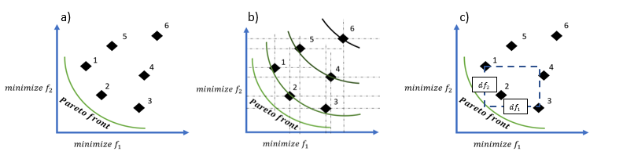

Figure 11.NSGA II sorting process illustration in a multi objective- minimize minimize optimization problem  
 . a) the population is randomly created. b) the population is divided by frontiers based on dominance with respect to each other . c) the population is sorted within the frontier with secondary method using the crowding distance metric.

# Method:

## The optimization problem:

As mentioned before, the works goal is to optimize the RVE density considering the mechanical and thermal constraints. One can define goal properties which are the designer's minimal and maximal stiffness and thermal conductivity respectively. Under those limitations, the designer purpose is to find the RVE which will result in the most lightweight structure.

The proposed problem can be defined as follows :

Minimize $ρ$

Subject to $E_{ii}≤E_{g}, G_{ij}≥G_{g}$

And $K_{ii}≤K_{g}$

Where $ρ$ is the material density,{ i,j}= 1,2,3 is the RVE main axes and $E_{g},K_{g}$ is the minimal directional stiffness and maximal directional heat conductance respectively.

## RVE Geometry and design variables :

The Geometry modeled in this work was inspired by a polycrystal metallic grain structures often found in high strength metals .In metals, the individual grains are arranged in a different directions resulting in a stiffer and higher strength material .

The modeled micro-structure is built in a similar manner. It consist of a grainy honeycomb-like structure reinforced with rigid directional fibers. Figure 10 shows a typical metallic grain structure and the suggested micro-structure. The presented structure is a composite- a hard and conductive phase (reinforcement phase) is combined with a relatively soft, lightweight and isolating phase(lightweight phase) to form the final micro-structure . The webs of the honeycomb is designed as a sandwich structure: stiff outer sheets filled within lightweight phase to enhance isolation capabilities and reduce the structure density. In addition, the lightweight phase is added to the inner volume of the cells to enhance load transfer capabilities and decrease the heat transfer of the micro-structure.

The RVE composed of 8 individual hexagonal cells with fibers oriented in independent directions to control the stiffness and thermal conductivity in selected directions .

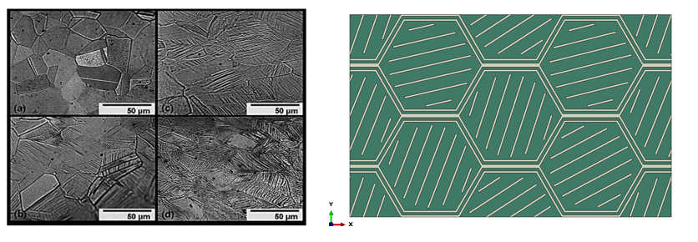

Figure 12. Metallic Grain structure and the suggested honeycomb based micro-structure reinforced with inclined fibers. The structure acts as a thermal maze which reduce the thermal conductivity of the structure. The inclined fibers allows control of both the thermal and mechanical properties in the selected direction. figure taken from [47].

## Parametric model generation :

The parametric model consists of 10 individual parameters as listed in Table 1. Parameters definition . and described in Figure 11 .The Web parameter describes the honeycomb web thickness, Iso describes the thickness fraction of the lightweight phase with respect to the web size. The cell angle parameters $θ_{ij}$ are the individual cell reinforcement angle. The fiber width ($f_{w})$, clearance( $f_{c})$ and the hexagon edge length (a) is defined by the previous parameters and the total RVE length (Xlength) which is set to be constant for easier comparison between the microstructure designs . The model is created as an external orphan mesh model which is imported to ABAQUS CAE [48] environment for the section assignment , simulation and post processing phase. The orphan mesh model is created using Python Gmsh [49] package which allows generating a periodically meshed geometry . A python script reads the parametric definition of the RVE data from a parameter space database and builds the RVE geometry using Gmsh built in commands. Then, a mesh periodicity constraint is made by linking opposite faces , edges and nodes of the final geometry. Finally , the geometry is meshed using 4 nodes linear tetrahedral elements(C3D4) for maximum robustness in the meshing procedure.

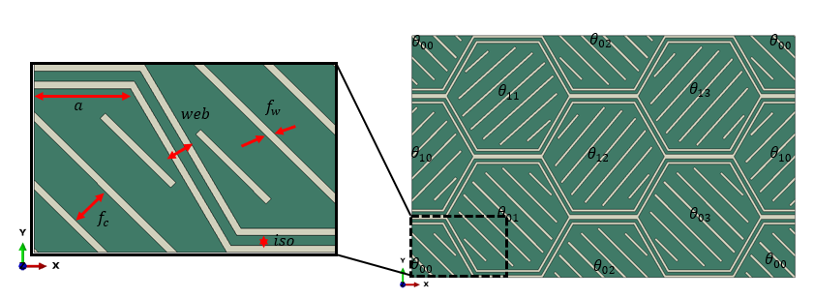

Figure 13. Suggested RVE parameterized definition. The RVE consists of honeycomb based structure with 8 individual cells reinforced in different angle. The peripheral cells are split to ensure the periodicity of the unit cell

|  |  |  |
| --- | --- | --- |
| Parameter name | Range values | Number of parameters |
| Web | [1,3] | 1 |
| Iso | [0.25,0.75] | 1 |
| $$θ_{ij}$$ | [0,180] | 8 |
| Fiber width ( $f_{w})$ | $$\frac{Web\left(1-Iso\right)}{2}$$ | - |
| Fiber clearance ( $f_{c})$ | 2Web | - |
| Hexagon edge length (a) | $$\frac{Xlength-4\left(Web-\cot\left(\frac{π}{3}\right)\right)}{8\left(1+\cot\left(\frac{π}{3}\right)\right)}$$ | - |
| Xlength | 50 | - |

Table 1. Parameters definition .

### Orphan mesh model creation :

As mentioned earlier , The orphan mesh model is created using Gmsh package and exported for the Thermal and Mechanical simulation in ABAQUS environment . The Parametric data is being read from a geometry parameter database created by the Latin Hypercube sampling script. The RVE building procedure starts from creating a quarter honeycomb cell using the previously gathered data. The quarter cell is mirrored about 2 axes to create the final 8 cell honeycomb structure . Next , The Reinforcement is added to the honeycomb cells using the angle parameters . The process starts with locating the centeral coordinates of each of the honeycomb cells and creating fiber pattern to the right and left using the fiber width, clearance and fiber angle values. The fibers are then trimmed using the inscribed circle inside the hexagon cells. Later, the fiber edges are altered to a rectangular shape ending in order to prevent keen angle formation . Hence, creating a simpler geometry and a more robust meshing procedure. The next step is perhaps the most crucial in the model creation process -Setting a periodic mesh. This step is made by enforcing periodicity constraint over the opposite RVE faces using Bounding box definition of the origin faces translated by the RVE relevant length. When the periodic couples are defined , the meshing procedure is made by Delaunay triangulation algorithm to create a 3D 4 nodes tetrahedral linear elements which can be converted to 8 nodes linear quad elements .

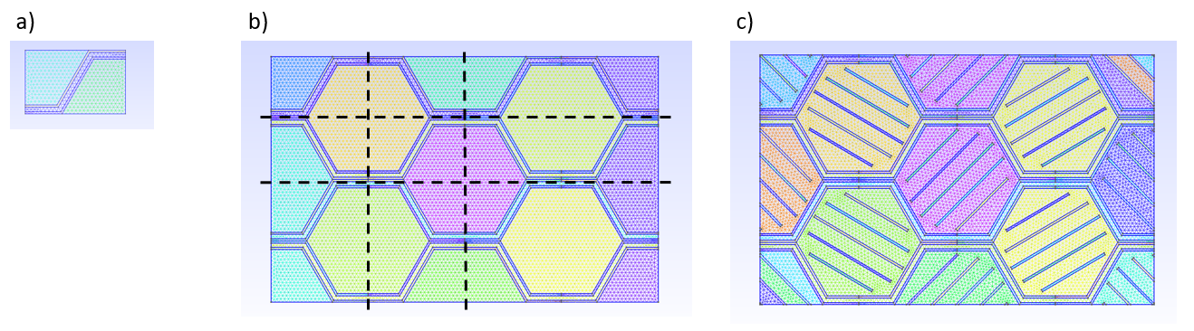

Figure 14. Orphan mesh model creation setup. a) a quarter honeycomb cell is created. b) the cell is mirrored in 2 directions to form the honeycomb base structure ( the mirror axes are marked in black). C) rectangular reinforcing fibers are created inside the hexagonal cells to form the final microstructure.

### Element size and type definition:

After the initial set up has been defined , element type and size need to be defined . A comparative test was made between first order Quad and Tet elements using the same seed value. Generally , using Tet elements ensures better robustness while meshing complex geometries in the cost shear lock errors which stiffens the model . Quad elements , are favorable in terms of numerical accuracy but having difficulties dealing with non trivial geometries . Table 4 summarizes the test simulation result . While using quad elements provided better accuracy by 1%-3% , it did result in almost double the runtime. Due to the large number of scheduled runs , its been decided to continue with the tet meshing.

|  |  |  |  |  |  |  |
| --- | --- | --- | --- | --- | --- | --- |
| Element Type | $$E_{11}$$ [GPa] | $E_{22}$ [GPa] | $$G_{12}$$ [GPa] | $$K_{11}$$ [W/mk] | $$K_{22}$$ [W/mk] | Runtime [s] |
| Quad | 5.077 | 5.925 | 2.090 | 0.646 | 0.497 | 474 |
| Tri | 5.181 | 6.074 | 2.157 | 0.649 | 0.502 | 254 |
| Difference | 2.04% | 2.51% | 3.20% | 0.40% | 1.00% | 86.0% |

Table 4. Mesh element choice results . Quad mesh resulted in slightly better accuracy but in a great numerical cost .

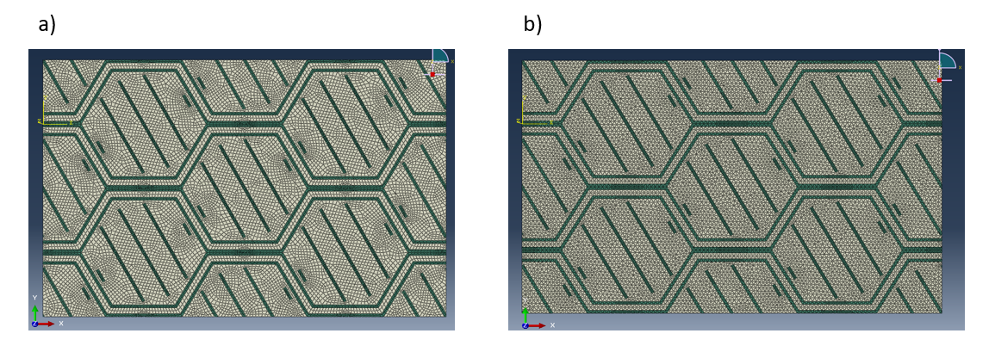

Figure 15. The selected RVE configuration meshed using a)First order Quad elements b) First order Tet elements. The meshing procedure was made using the same seed size.

### Mesh Convergence:

Convergence test of the simulation has been conducted using different RVE geometries (Honeycomb pattern) .Figure 1 summarize the test results . It is to be noted that as the simulation mesh refines, both the RVE modulus of elasticity as well as the thermal conductivity decreases toward the accurate values .While the simulation error decreases , the calculation time increases exponentially. One can say that an optimum point between the simulation error and simulation time exist in the 60,000 elements point (seed size of 1/100 the RVE size). This type of mesh will result in 3,2,5 precent maximum error for E1,E2,G12 for the mechanical case and 0.7,1 precent maximum error for K1,K2 for the thermal case in the calculation time of approximately 360 seconds per design .

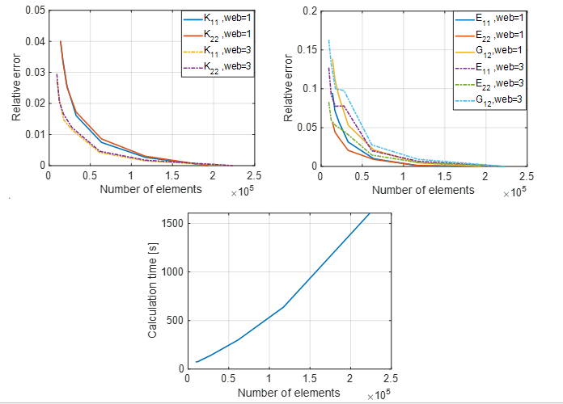

Figure 16. Element size convergence result. As the number of elements increases the model equivalent modulus and conductivity decreases towards the true value . While the accuracy increases, the calculation time grows exponentially . An optimum point lies in the 60,000 or 1/100 seed size of the RVE length. This enables completing a full simulation cycle in 6 minutes.

### Material selection :

Material selection is of great importance in our design problem. The properties of the constituent phases will have a major impact both of the property range that can be achieved and on the final optimized geometry. The Reinforcement phase provides the strength and stiffness for the new composite material while the matrix phase has to provide the load transfer , heat isolation capabilities and reduce the average density of the RVE . In addition, the constituents has to be able to keep their mechanical properties in midrange operating temperatures. Under the following requirement and constrains , we can use Ashby [50] charts to fit our selection criterion Figure 12,13:

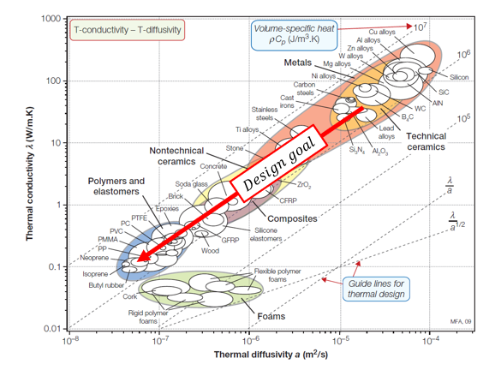

Figure 17. Thermal conductivity-Thermal Diffusivity material chart . The design goal is to minimize them both resulting in the polymers family being the most suited candidate. Chart taken from [50]

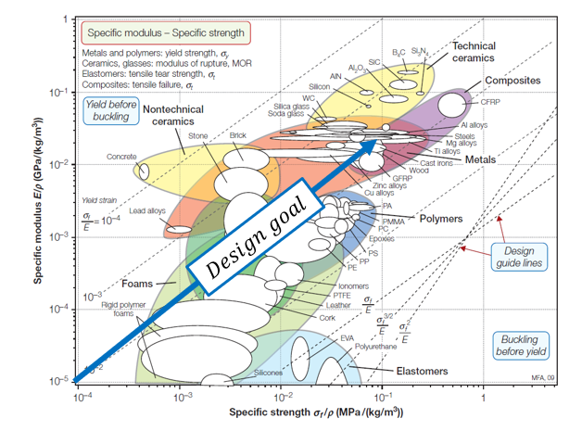

Figure 18. Specific strength -specific modulus material chart . The design goal is to maximize them both. Optional families include ceramics and metals. Chart taken from [50]

Observing at Figure 13 we can see that the Ceramics and metals families are best fitting our reinforcement criterion due to high specific modulus and specific strength (modulus/strength to weight ratio). Some of the candidates include Alumina $(Alo_{2})$,Zirconia $(Zro_{2})$ and Glass .Titanium (Ti) is also a decent choice due to its high specific strength and modulus as well as low thermal conductivity relative to the ceramics.   
 High temperature Polymers is fitting our matrix requirement due to their low density and thermal conductivity. Some of the popular choices for PMC for high temperature environment include: bismaleimide (BMI),Polyimide(Pi) and Cyanite ester resin. Summary of the reinforcement and matrix candidates in Table 2, Table 3.

|  |  |  |  |  |  |  |  |
| --- | --- | --- | --- | --- | --- | --- | --- |
| Name | Density  [Tonne/m^3] | Modulus of elasticity  [GPa] | Failure strength  [MPa] | Elongation | Thermal Conductivity  [W/mk] | Max service temp[C] | Manufacturing |
| Ti-6av | 4.45 | 110 | 1170 | 10% | 7.1 | 900 | 3D,CNC |
| Macor (Machinable Glass) | 2.52 | 66.9 | 94 | 4-5% | 1.4 | 700 | CNC |
| Alumina | 3.9 | 350 | 460 | 0.1% | 30 | 1000 | CNC |
| Zirconia | 5.6 | 200 | 330 | 0.2-0.3% | 3 | 500 | CNC |

Table 2. Reinforcement phase material properties

|  |  |  |  |  |  |  |  |
| --- | --- | --- | --- | --- | --- | --- | --- |
| Name | Density  [Tonne/m^3] | Modulus of elasticity  [GPa] | Failure strength  [MPa] | Elongation | Thermal Conductivity  [W/mk] | Max service temp[C] | Manufacturing |
| Polyimide | 1.42 | 2.5 | 50-150 | 3% | 0.12 | 300 | Hot compression moulding |
| Cyanite ester | 1.2 | 2.9-4.3 | 50-150 | 5% | 0.2-0.4 | 350 | Casting |
| BMI | 1.2 | 3.5-4.5 | 50-150 | 4% | 0.3 | 250 | Casting |

Table 3. matrix phase material properties

Although Glass reinforced plastic may be the proper choice for obtaining the best isolation capabilities from the microstructure while maintaining relatively high stiffness , the similarities in the thermal conductivities would cause a very shallow response surfaces , making the thermal optimization part of the study irrelevant .Therefore, For the research purpose Ti-Pi constituent combination was used . Both of the constituents differentiate greatly in the thermal, elastic and density properties ,Thus enhancing the gradients of the multidimensional response surface .

## Equivalent Elastic properties calculation:

The previously defined RVE model is simulated using five different loading scenarios -three for the directional elastic constants ${(E}_{11},E_{22},G_{12})$ and two for the thermal conductivity constants ${(K}_{11},K_{22})$. The elastic simulation and periodic boundary conditions set up is made by easyPBC ABAQUS plug in developed by Sadik L. Omairey [51]. Given an RVE with a periodic mesh, the software is using mechanical homogenization method and periodic boundary conditions to calculate the RVE effective elastic properties . First , the opposite facing nodes of the meshed RVE are found and linked using search algorithm . Then, the linked node sets are constrained to the master corner nodes displacements using ABAQUS constrains. The unit cell is then imposed by uniform strains at the master nodes according to the selected loading scenario. Finally, The effective properties are calculated using the reaction forces generated by the loading scenario, averaged over the overall RVE relevant surfaces the imposed strains \ref{eq1},\ref{eq2} . The default strain value for all directions was changed to 0.2% of the specific direction length scale in order to be consistent with the physical definition of Elastic region. RVE measurements and strain definition is presented in Figure 15. Typical elastic response of the purposed RVE in $E_{11},E_{22},G_{12}$ loading scenario can be seen in Figure 15.

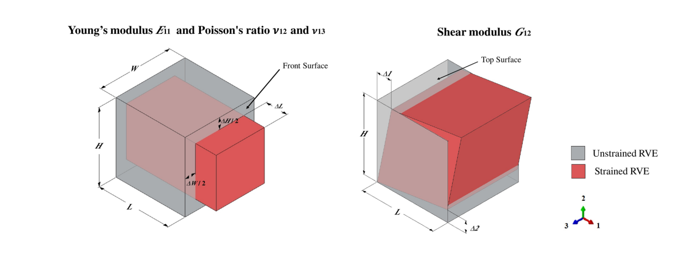

Figure 19.RVE Measurements and strained definition for Young and Shear modulus .Figure taken from [51]

(13) $E_{ii}=\frac{\frac{ΣFront nodel forces_{i direction}}{Front surface area \left(H*W\right)}}{ϵ_{ii}}$

(14) $G_{12}=\frac{\frac{Σ Top nodal forces_{1 direction}}{Top surface area\left(L*W\right)}}{\frac{Δ1}{H}+\frac{Δ2}{L}}$

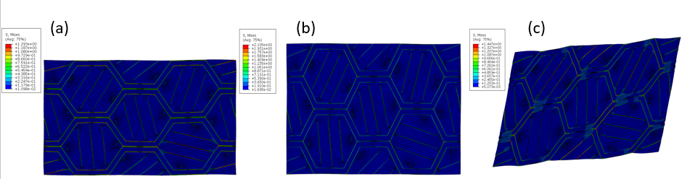

Figure 20. Mechanical loading response of the RVE a) $E_{11}$ Loading. b) $E_{22}$ loading.c) $G_{12}$ loading. The RVE deformation is periodic to simulate a deformed physical space filled with RVE deforming in the same manner

## Equivalent Thermal properties calculation:

#### The Thermal RVE homogenization is made with a steady state heat transfer simulation using Micro-Mechanics plug in for imposing periodic BC and job creation, and by a Python script to make the post processing phase .For the calculation of the effective thermal conductivity, a uniform temperature gradient of 1 degree is set on the front and back RVE faces respectively .Typical temperature distribution for $K_{11},K_{22}$ loading is presented in Figure 16.

The effective conductivity is calculated by using steady-state 1D heat equation Eq 11 discretized by the model elements. The normal thermal flux values are extracted from the individual model elements, averaged over the RVE volume and multiplying by the RVE length scale using Eq 12 .

(15) 

(16) 

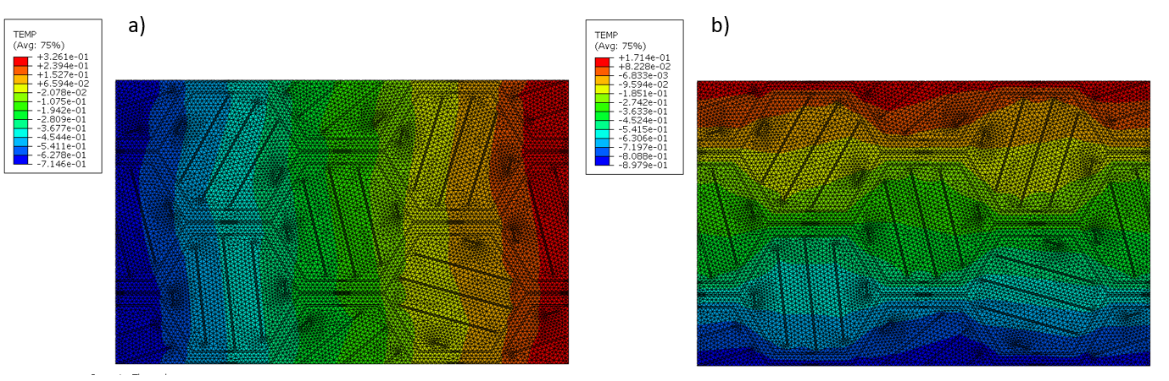

Figure 21. Thermal load case for $K_{11},K_{22}$ The RVE is loaded in equal temperature difference between the selected direction opposite faces. The equivalent properties are calculated in the post process phase using the directional heat flux averaged over the RVE volume.

## Surrugate based optimization :

As mentioned in the background chapter , the optimization task done in this project is involving surrogate based optimization. Direct optimization typically involves exploration of a small portion of the design space, making the task of understanding the trade off relation in the model as well as validating the optimized solution very difficult. In addition, in direct optimization the designs are generated during the optimization process . This process generally requires generating and simulating hundreds to thousands of designs with computational time of days to weeks . In case the designers goals and objectives will change , the simulation task has to be made from scratch.   
In surrogate based optimization , a different approach is taken. First , a geometrical database is created using DOE algorithm to span the design space in a space efficient matter . The database is then fed as input for the simulation routine to calculate the effective properties for each of the generated designs – Elastic , Thermal and density . On the second step , the previously generated Geometric-Effective properties database is used to train a reduced order surrogate model . Using this model, allows quick and accurate prediction for the equivalent properties given the geometrical features . On the third step , the optimization is made directly on the surrogate model . Using this method , allows the designer to have a full parametric space view , quick convergence to the pareto and great flexibility while determining the optimizations objectives and goal. A 2000 design cases direct optimization will take approximately 1 week vs 0.2 seconds while using the surrogate for the optimization.   
The Surrogate model can be used for optimization in the designer side , enabling exploration of the different trends ,optimizing and obtaining the final result without the need to use Finite Elements Method or special computational power . Some of the known models includes polynomic based models , Neural Network ,Gaussian process etc.   
In this work, we explored both Gaussian process and Neural network models using the generated dataset in terms of prediction accuracy and training time.

### Surrogate models calibration and comparison:

A comparison Between GPR and Shallow Neural Network was made. The comparison was made using Matlab [52] functions (nnfit,fitrgp) with 5 fold validation technique. Table 5 summarize the comparison result. The comparison shows slightly better accuracy for GPR in comparison to NN but in a great numerical cost due to the inversion of matrix in the regression process .Although its inferior prediction performance, NN model was chosen for the surrogate modeling due to its low numerical cost and ability to predict multiple variables at the same model. In addition, The quick training time of the Neural Net model allows a rapid improvement using optimization process of the net parameters (number of neurons in the hidden layer, Back propagation algorithm and transfer function) with respect to the net accuracy. The optimized Net showed a significant increase in the prediction accuracy using fully connected 50 nuerons hidden layer, Bayesian Regularization back-propagation and 'MSE' performance function with proportional error to account for the relative error.

|  |  |  |  |
| --- | --- | --- | --- |
| Regression Method | $$R^{2}$$ | RMSE | Runtime [s] |
| GPR | 0.93 | 0.0495 | 870.37 |
| NN | 0.91 | 0.0558 | 185.4 |

Table 5. Regression models comparison. Gaussian process regression shows better accuracy but at a large training cost due to the matrix invertion in the training process.

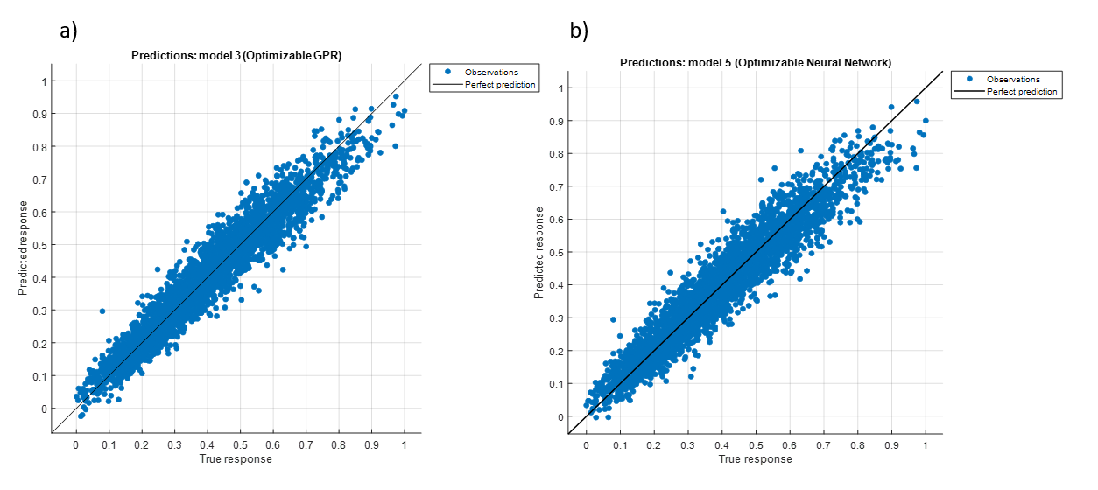

Figure 22. Graphic representation of the prediction accuracy of a) Gaussian process regression . b) Shallow Neural Net. The black line represents perfect prediction while the blue samples are the model prediction

First , an optimization for the number of neuron has been conducted , altering the number of neurons in the hidden layer and saving the training and test accuracy.  
In order to test the different networks on the same training and validation/test data, The data was partitioned into training (70%) , validation(15%) and test data( 15%) using indexed partition .  
as showed in Figure 21 the optimization result ,show an interesting result – increase on the number of neurons up to 50 brings an increase in the prediction accuracy for both the training and the test data. As the number of neurons exceeds 50, the training accuracy is increasing while the test accuracy is deteriorating .As the network size increases , it has the ability to memorize the training data and stops the generalization process -overfitting .

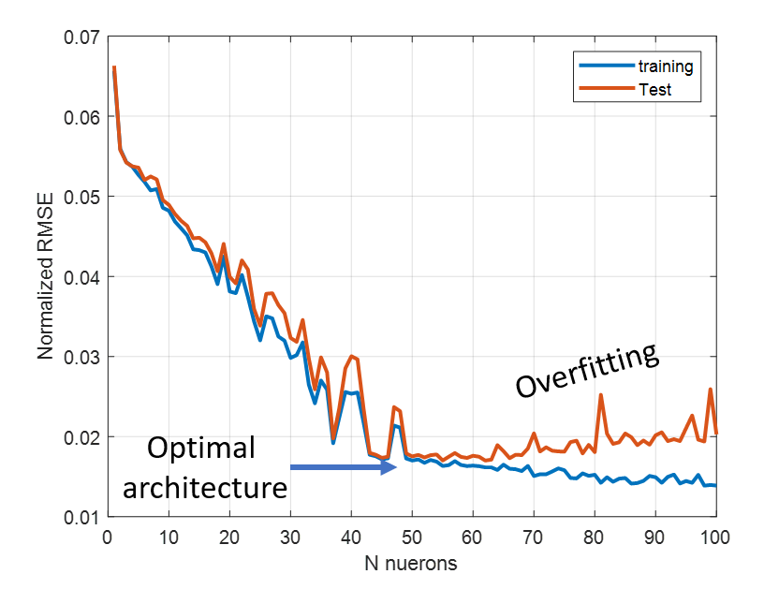

Figure 23. Net prediction accuracy as a function of the number of neurons in the hidden layer . increasing the number on Nuerons from 1 to 50 results in an improvement trend for both the training and test set. Further increase of the neurons results in overfitting-improvement for the training set and decline in the test set accuracy.

According to the optimization result, the net architecture has been set to have 50 neurons in the hidden layer. The final net architecture and the normalized prediction accuracy is shown in Figure 22, Figure 23.

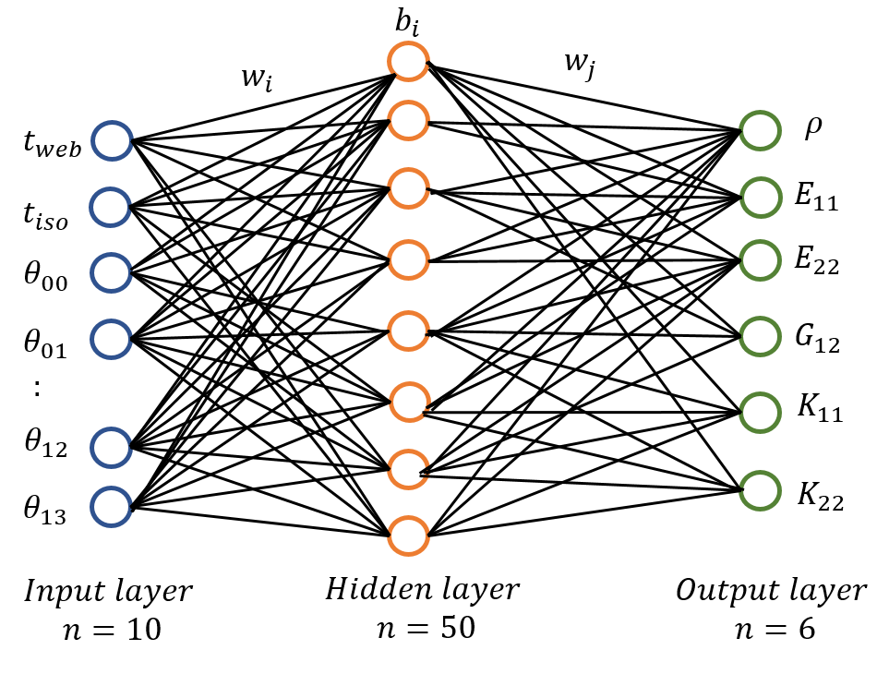

Figure 24. Optimized net architecture



Figure 25. NN optimized model accuracy graphical representation. The orange line represents perfect prediction while the blue samples are the model predictions.



Figure 26.Errror percentage histogram for the 750 (15%) test samples . The model prediction produced decent results , with 99% of the samples are bounded within 4.52% prediction error .

Additional testing was taken to measure the database size on the net prediction accuracy. The testing was made using the same net architecture and training algorithm. Partial datasets was taken randomly out of the original 5000 datapoints ranging from 500 datapoints to full 5000 points. To prevent localization sampling of the design space-The net was trained 10 times for each subset size using different dataset. The test accuracy was averaged to measure the general accuracy trend. The results can be viewed in Figure 24. Although 5000 datapoint database was generated, the prediction accuracy did not improve significally increasing the database size over 2000 samples.



Figure 27. NN model prediction accuracy as a function of the samples database for the present study a 2000 database size produces decent result for 10 predictors and 6 responses.

### Exploring the design space :

After the Neural net model was trained and optimized , it can be used for the parametric space exploration phase. Using the model enables a continuous view of the design space with respect to the different properties, improving our physical understanding of the trade off relation and parameter interaction. In order to have basic understanding for the parameter interaction several design cases were studied where in each of them, some parameters was kept constant while others remained free to change within the predefined bounds. The Exploration Started with un reinforced honeycomb ( 2 parameters) , reinforced with equal angle (1,2 parameter) dual equal angle (2 parameters ) and random space ( 10 parameters ) .

#### Empty honeycomb (2 parameters)

The first step is to explore empty honeycomb structure itself , 200 design cases were simulated with varying web thickness and isolation fraction of the web. Typical microstructures are shown in Figure 25 ,continuous mapping is shown in Figure 26. Looking at the response surface charts ,we see a similar picture for all of the effective properties – as the web size increase and the isolation fraction decrease we have an increase on the mechanical ,thermal and density of the RVE.

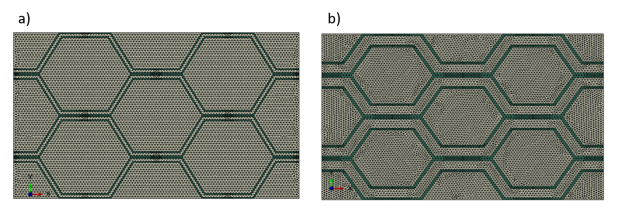

Figure 28. Empty honeycomb microstructure examples. Varying the web and iso parameters .

|  |
| --- |
|  |
|  |
|  |

Figure 29.Response surface GPR approximation of the un reinforced honeycomb structure. The sampled points are shown in black on the response surface plot. a) ${Modulus of elasticity E}_{11}$. b) $Modulus of elasticity E_{22}$. c) ${Shear Modulus of elasticity G}_{12}$. d) $Structure density ρ$. e) ${Thermal conductivity K}_{11}$. f) ${ Thermal conductivity K}_{22}$

#### Reinforced with equal angle (1 parameter)

The next step, was checking the fibers contribution to the elastic and thermal properties on the extreme case , when all of the fibers are tilted in the same angle (Figure 27 ). The result are presented in Figure 29 .Examinig the results in the mechanical side, we can see that as expected ,the global maximum value of E11 and E22 are obtained in 0 and 90 deg respectivlty. Interestingly, the young modulus has a second local maxima located in 90 and 0 respectively. The perpendicular fibers , Stiffens the honeycomb structure , preventing from the individual cell wall to bend and collapse. For the shear modulus, the maximum values are obtained in +-45 deg as expected.  
As for the thermal picture , The global minimum is obtained in 90 and 0 for $K_{11}$, $K_{22}$ respectevlty. The equal angle case demonstates the inherent conflict between the mechanical and thermal case – increasing the stiffness in a specific direction comes along with increase in the thermal conductivity .

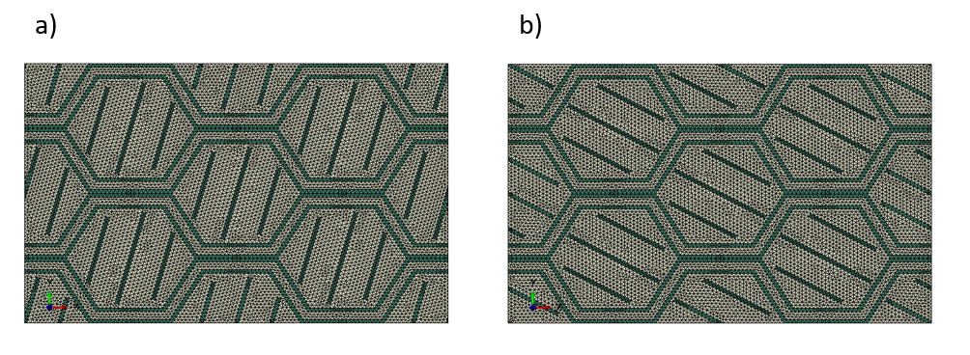

Figure 30.Reinforced with equal angle microstructure.

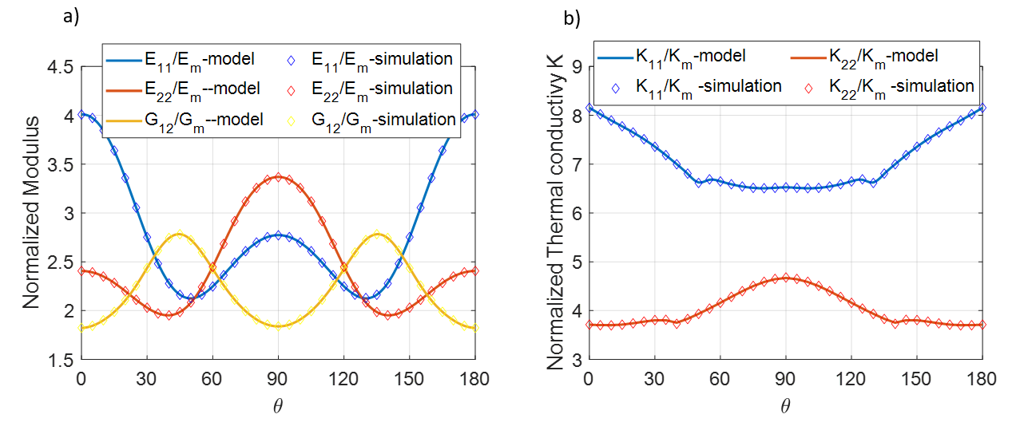

Figure 31.Reinforced with equal angle simulation and model result. a) Normalized elastic properties. b) Normalized thermal properties. The thermal and the elastic constants having are positively correlated with respect to the reinforcement angle .

## Reinforced with dual angles*( 2 parameters)*

Another test has been conducted enabling the RVE’s fibers to be oriented in 2 different angles to examine different angle fibers interaction result. In order to set all 8 cells a randomized angle , each angle sets the orientation of 4 individual cells according to Table 6 and Figure 30 .

|  |  |  |  |  |  |  |  |  |
| --- | --- | --- | --- | --- | --- | --- | --- | --- |
| Cell | (0,0) | (0,1) | (0,2) | (0,3) | (1,0) | (1,1) | (1,2) | (1,3) |
| Fiber angle | $$θ_{1}$$ | $$θ_{2}$$ | $${-θ}_{1}$$ | $$-θ_{2}$$ | $$θ_{1}$$ | $$θ_{2}$$ | $${-θ}_{1}$$ | $${-θ}_{2}$$ |

Table 6. Dual angle configuration cell reinforcement angle definition.

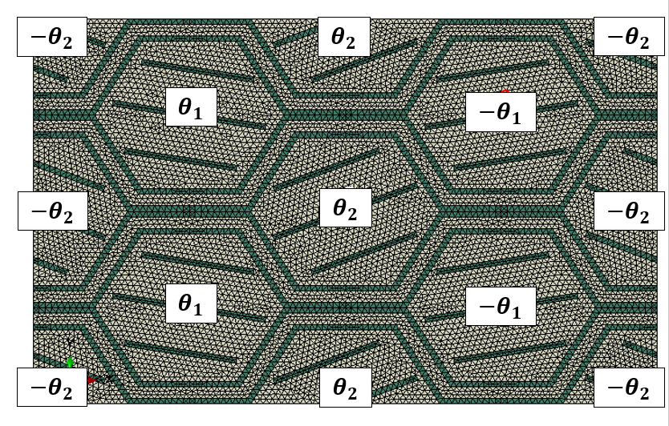

Figure 32. Dual angle configuration graphic definition.

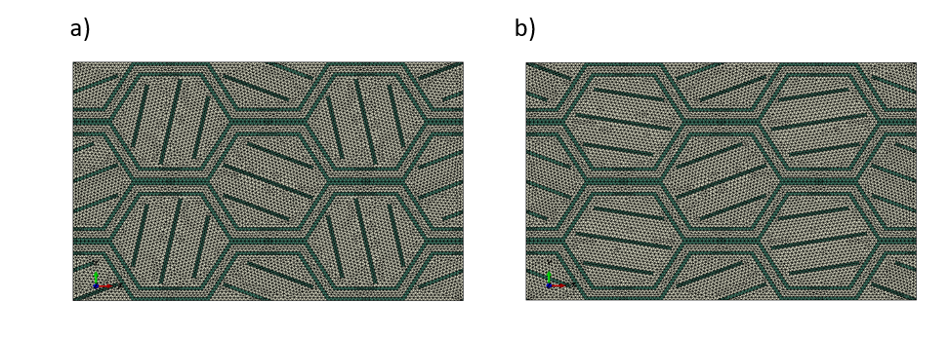

Figure 33. Dual angle case representative microstructures.

Figure 32 shows the response surface of the unit cell to the change of the angle paramerters . The elastic constants show a similar result to the previously single angle case where the maximal values appear at 0,90,45 angles for $E_{11},E_{22},G_{12}$ respectivly.In addition, the single angle case can be seen as a diagonal cut through the diagram where $θ_{1}=θ_{2}$.

.For the thermal case , we can see that the combination of $0,45 or 90,45$ degree angle bring the thermal conductivity to a minimum by forming a thermal maze (Figure 33 ) .

|  |
| --- |
|  |
|  |
|  |
|  |
|  |

Figure 34.Dual angle simulation and model normalized result. The simulated design points are marked as black dots on the response surface plot. a) $E_{11}$ surface plot. b) $E_{22}$ surface plot. c) $G_{12}$ surface plot .d) $K_{11}$ surface plot. e) $K_{22}$ surface plot

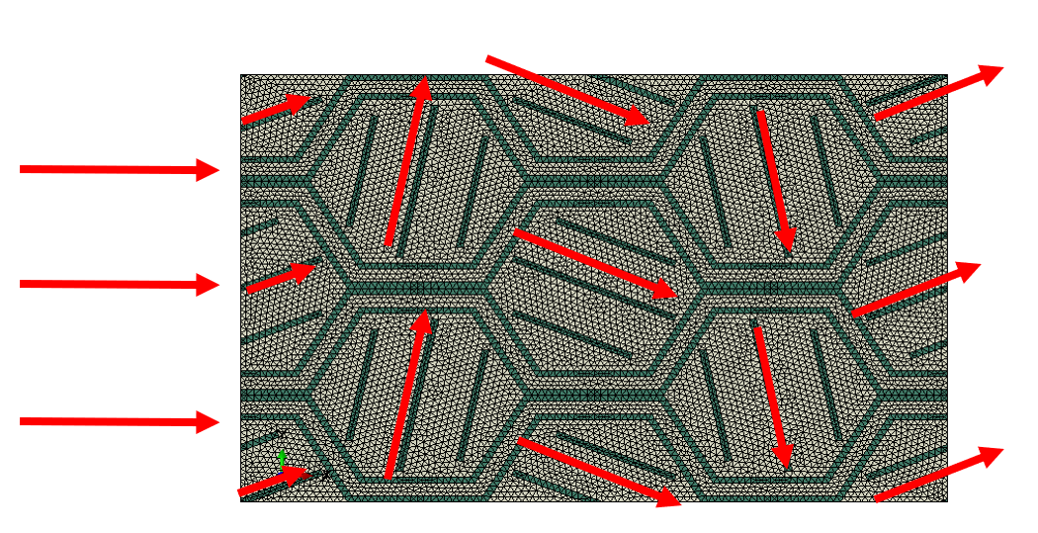

Figure 35. Thermal maze configuration. The thermal flux is scattered using alternating fiber angles ,decreasing the thermal conductivity by increasing the effective distance .

#### Reinforced with changing web and equal angle

The last test case has been made to test the web-theta relation . Due to the constant size definition and the parameters relations , a big web size is results in thicker fibers and in a smaller cell interior which leads to a decreased amount of reinforcing fibers per cell . We can see that as the web size decreases , the fibers domination in determining the RVE’s properties is increasing .

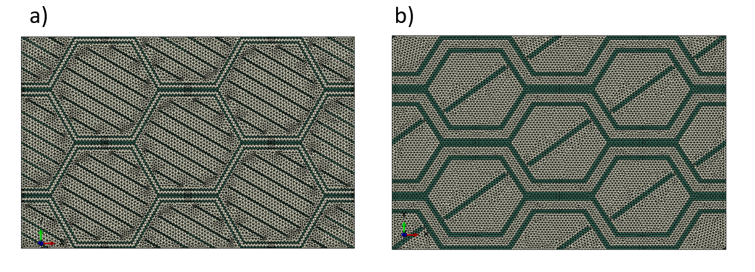

Figure 36.Web and angle representative microstructures. The fiber clearance(density) definition is using the web parameter, causing lower web to increase the fiber density in the honeycomb cells.

|  |
| --- |
|  |
|  |
|  |
|  |
|  |
|  |

Figure 37.Web and angle simulation and model result. The simulated design points are marked as black dots on the response surface plot. a) $E_{11}$ surface plot. b) $E_{22}$ surface plot. c) $G_{12}$ surface plot .d) $K_{11}$ surface plot. e) $K_{22}$ surface plot. f) $ρ$ surface plot.

#### Full design space exploration:

After grasping the effect of the geometry parameters on the effective engineering constants as well as the trade off relation between the objectives , a full design space parametric study has been conducted . The run was made using 5000 design points to span the 10 dimentional parameters space . The results are presented below

|  |
| --- |
|  |
|  |

Figure 38.Full design space exploration graphs. a) Normalized $K_{22}$, $E_{22} and ρ$. b) normalized $E_{22},E_{11} and ρ$. c) normalized $G_{12} ,E_{11} and ρ$. d) normalized $K_{22},K_{11} and ρ$. The trade off relation between the thermal ,elastic and density objectives can be observed . Higher density designs typically having better elastic properties and worse thermal resistance properties.

## Optimization:

### Goal based optimization:

A Surrogate based optimization process was made using the previously generated database and the optimized Net .At first ,a mathematical objective function was created to grade the designs based on the designer's goal properties $E_{ii}\left(goal\right),G_{ij}\left(goal\right), K_{ii}\left(goal\right)$ and the resulted micro-structure properties with a single grade . The function was built so that the grade will be based mainly on fulfillment of the minimum stiffness and maximum conductivity goal requirements. If those are attained, an additional grading will be given based on the structural mass. To achieve this task ,We can define a relative values with respect to the predefined goal values . The relative values formulation was designed so that it takes a negative sign while the microstructure has attained the minimum stiffness and maximum conductivity values. Thus, decreasing the overall objective function value . The relative properties are defined as follows :



based on those definitions ,we can define our goal and objective function based on the weighted sum method for the thermal and elastic constants grading using the relative properties , and tanh activation function to determine the weighting for the density objective with respect to the goal values attainment. The objective function is defined as following :





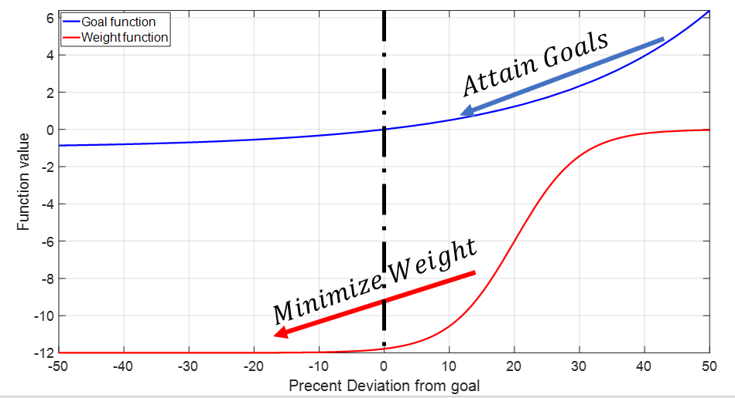

Figure 39. Goal -U(x) and activation function- w(x) graphic representation. The goal function U(x) is defined using exponential term to increase the penalty value for designs whose properties are the furtherst from the predefined goal values . The activation function W(x) is defined using tanh function to activate the density grading upon the fullfillment of the goal values.

looking at the objective function definition together with Figure 35 we can see that The goal function value is decreasing exponentially as the RVE properties is reaching our goal properties . In addition , tanh() activation function is used for the density grading with respect to the designer goals .as the RVE properties is approaching the goal values , the activation function gives better weight for the structural density, Thus aspiring goal fulfillment and then minimization of the structural weight.

#### Goal optimization result:

A first iteration of the optimization process was taken care defining goal values of $E_{Goal\left(11\right)}=7.3\left[GPa\right];K_{goal(11)}=0.6[\frac{W}{mK}]$ 
 . The optimization routine was built with MATLAB ga() function and the previously defined single objective goal function. The optimization yielded a better solution then those simulated to span the design space in terms of the objective, demonstrating the value in surrogate based optimization. Table 7 and Figure 38 show the optimization result and the resulting microstructure . In order to keep with the goal requirements , the web size decreased to a minimum while the isolation fraction value was increased to maximum. In addition , the fiber cell angle was set to be 0 deg , Thus reinforcing the structure in the goal direction.

|  |  |  |  |  |  |  |  |  |  |  |
| --- | --- | --- | --- | --- | --- | --- | --- | --- | --- | --- |
| Parameter | web | iso | $$θ_{00}$$ | $$θ_{01}$$ | $$θ_{02}$$ | $$θ_{03}$$ | $$θ_{10}$$ | $$θ_{11}$$ | $$θ_{12}$$ | $$θ_{13}$$ |
| Value | 1 | 0.75 | 0.01 | 0.01 | 0 | 180 | 0 | 179.97 | 0.02 | 180 |

Table 7.Optimization result -Geometrical parameter for goal values $E_{11\left(goal\right)}=7.3\left[Gpa\right],K_{11\left(goal\right)}=0.6 [\frac{W}{mK}]$. The optimization resulted in equally aligned 0 degree fibers with minimum web size and maximum iso values.

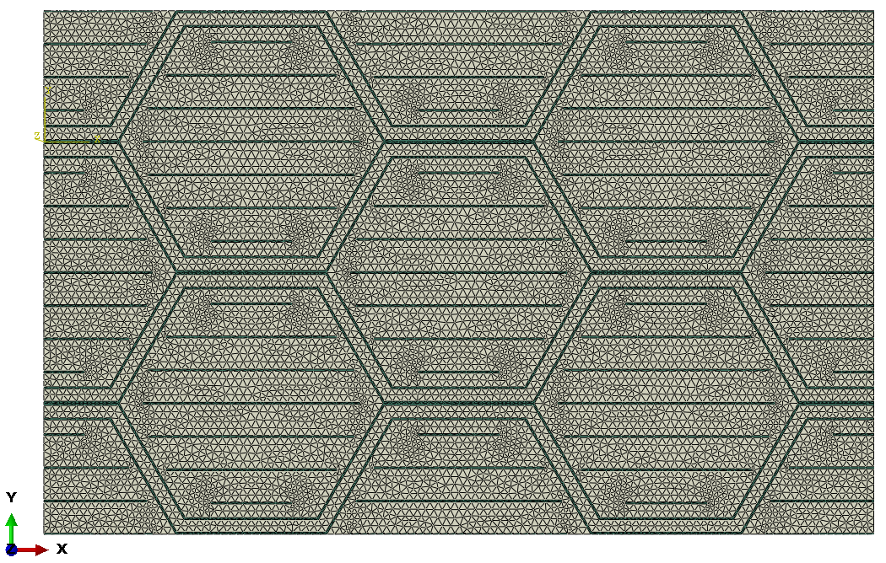

Figure 40. Optimization result -model configuration for goal values $E_{11\left(goal\right)}=7.3\left[Gpa\right],K_{11\left(goal\right)}=0.6 [\frac{W}{mK}]$. The optimization resulted in equally aligned 0 degree fibers with minimum web size and maximum iso values.

|  |  |  |  |  |  |  |  |  |
| --- | --- | --- | --- | --- | --- | --- | --- | --- |
|  | $$ρ[\frac{Tonne}{m^{3}}]$$ | $$E_{11}[GPa]$$ | $$E_{22}[GPa]$$ | $$G_{12}[GPa]$$ | $$K_{11}[\frac{w}{mK}]$$ | $$K_{22}[\frac{w}{mK}]$$ | $ϕ-$ Obj | Best Obj |
| predicted | 1.68 | 7.36 | 4.50 | 1.07 | 0.474 | 0.23 | -4.61 | -2.86 |

Table 8. Optimized model result -Surrogate model for goal values $E_{11\left(goal\right)}=7.3\left[Gpa\right],K_{11\left(goal\right)}=0.6 [\frac{W}{mK}]$.

Second optimization case was made defining $G_{12\left(goal\right)}=2.21\left[GPa\right],K_{22\left(goal\right)}=0.6[\frac{W}{mK}]$. The resulted parameters and geometry can be seen in Table 9 and Figure 39. The resulting micro-structure is built using minimum web thickness and alternating diagonal fibers to increase shear modulus while minimizing the thermal conductivity using the thermal maze concept( Figure 33).

|  |  |  |  |  |  |  |  |  |  |  |
| --- | --- | --- | --- | --- | --- | --- | --- | --- | --- | --- |
| Parameter | web | iso | $$θ_{00}$$ | $$θ_{01}$$ | $$θ_{02}$$ | $$θ_{03}$$ | $$θ_{10}$$ | $$θ_{11}$$ | $$θ_{12}$$ | $$θ_{13}$$ |
| Value | 1.02 | 0.358 | 142.3 | 38.7 | 133.2 | 40.7 | 140.0 | 136.6 | 137.6 | 49.6 |

Table 9. .Optimization result -Geometrical parameter for goal values $G_{12\left(goal\right)}=2.21\left[Gpa\right],K_{11\left(goal\right)}=0.6 [\frac{W}{mK}]$. The optimization resulted in minimum web structure and alternating fiber angles to increase the shear modulus and form thermal maze.

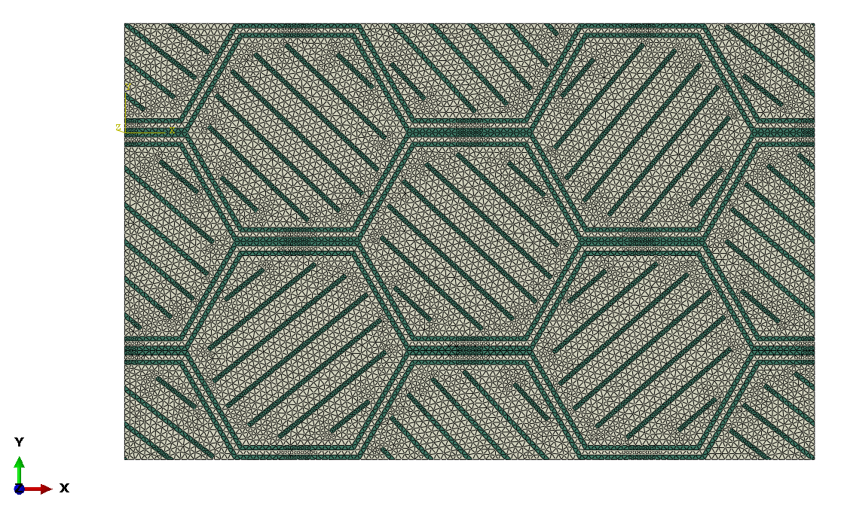

Figure 41. Optimization result -model configuration for goal values $G_{12\left(goal\right)}=2.21\left[Gpa\right],K_{11\left(goal\right)}=0.6 [\frac{W}{mK}]$. The optimization resulted in minimum web structure and alternating fiber angles to increase the shear modulus and form thermal maze.

|  |  |  |  |  |  |  |  |  |
| --- | --- | --- | --- | --- | --- | --- | --- | --- |
|  | $$ρ[\frac{Tonne}{m^{3}}]$$ | $$E_{11}[GPa]$$ | $$E_{22}[GPa]$$ | $$G_{12}[GPa]$$ | $$K_{11}[\frac{w}{mK}]$$ | $$K_{22}[\frac{w}{mK}]$$ | $ϕ-$ Obj | Best Obj |
| predicted | 2.05 | 5.00 | 4.67 | 2.65 | 0.687 | 0.451 | -4.61 | -2.86 |

Table 10. . Optimized model result -Surrogate model for goal values values $G_{12\left(goal\right)}=2.21\left[Gpa\right],K_{11\left(goal\right)}=0.6 [\frac{W}{mK}]$.

|  |  |  |  |  |  |  |  |  |
| --- | --- | --- | --- | --- | --- | --- | --- | --- |
| $$α$$ | $$β$$ | $$γ$$ | $ρ$**[Tonne/m^3]** | $E_{11}$**[GPa]** | $E_{22}$**[GPa]** | $G_{12}$**[GPa]** | $K_{11}$**[W/mk]** | $K_{22}$**[W/mk]** |
| 4 | 20 | 10 | 1.87 | 6.97 | 4.98 | 1.65 | 0.598 | 0.349 |
| 4 | 10 | 10 | 1.83 | 6.47 | 5.31 | 1.65 | 0.506 | 0.331 |
| 8 | 20 | 10 | 1.97 | 7.31 | 6.43 | 1.52 | 0.603 | 0.408 |

Although the optimization routine did produce decent results, it was found to be extremely sensitive to functions parameters- each combination of the function yielded a different best solution, giving different weighting for the Goal/Weight objectives. Example iterations for the calibration of the objective function and the optimization result can be found on Table 11.Decreasing $β$ value results in greater tolerance for missing the optimization goals in the tanh activation function. This produces further weighting for the density requirement at the expense of the stiffness constraint. Increasing $α$ value causes steeper gradient for the change in the properties with respect to the goal properties , resulting in a heavier weighting for the goal requirements (Figure 41). The use the parameter set of [8,20,10] for $α,β,γ$ respectively yields an acceptable solution that accomplishes the goal values requirement.

Table 11. Objective function parameters and the resulted best solution for $E_{11\left(goal\right)}=7.3\left[Gpa\right],K_{11\left(goal\right)}=0.6 [\frac{W}{mK}]$.

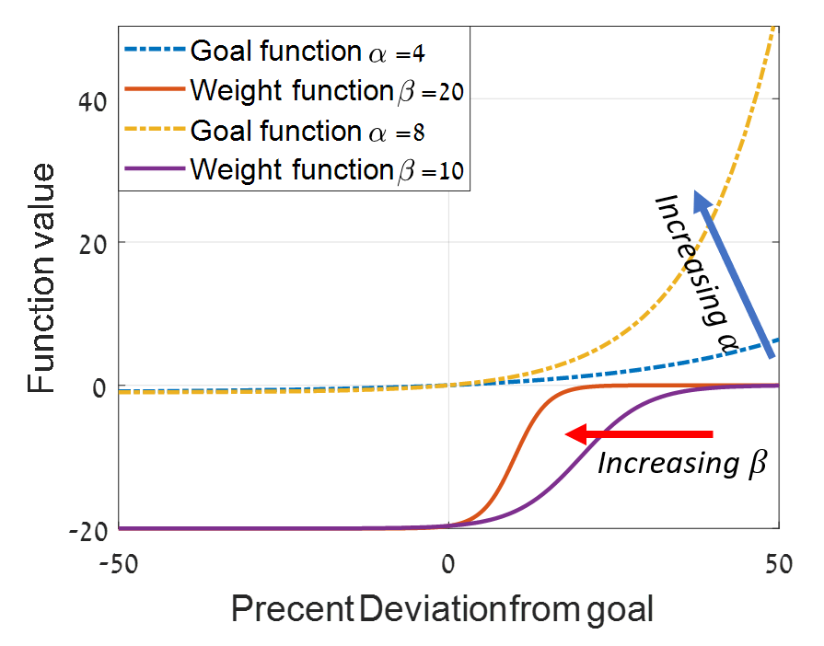

Figure 42. Activation (Weight) and Goal function as function of the function parameters . Increase in $β$ value decreases the tolerance for not obtaining the goal values , Increase in $α$ value increase the weight of the RVE properties at the expense of the structural density.

As mentioned in [53],The use of a single objective function with weighting parameters for multi objective optimization purpose , affects the obtained solution greatly . The aspiration to find a singular best solution for multiple objective problem was found to be subjective and confusing .  
Therefore, a different approach must be taken- multi-objective optimization.

### Multi objective optimization using NSGA II

Multi objective optimization deals with optimizing multiple objectives simultaneously. The idea behind the method comes from the concept that in most cases in multi-objective optimization , an increase in one objective comes with decrease in others . Therefore , for every change in one objective there is best solution with respect to the rest of them. There is no single “best” solution but a group of them( Pareto Frontier). Using this process , eliminates the need to use of a subjective collective objective function. In addition, it allows the designer to see the full collection of the best solutions , grasp the tradeoff relation between the individual objective and select the best possible solution within his selection criteria. Figure 42 shows an example of multi-objective result for maximizing $G_{12}$,minimizing $k_{22}$ and $ρ$. The solution space is presented in the top left corner , The pareto front represents the group of the best solutions within the feasible space . On the Pareto frontier, Each Stiffness value has different best solution with respect to both the conductivity and density.

The optimization process was made using NSGA II multi objective genetic algorithm. As a multi-objective algorithm, it differs from a regular genetic algorithm by its grading system. While regular genetic algorithm grades the designs based on collective objective function, NSGA II sorts the designs to frontiers using dominance on each of the objectives with respect to other designs in the solution space . The optimization routine was made using MATLAB built in function gamultiobj() for Maximizing the stiffness constants while Minimizing the RVE density and conductivity .

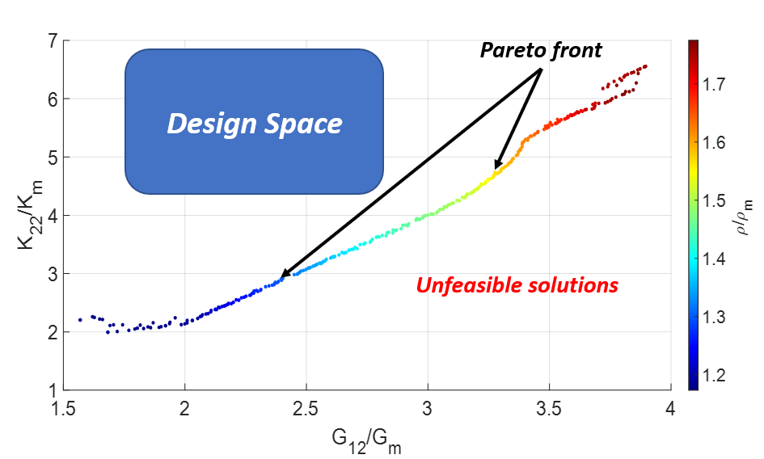

Figure 43. Pareto frontier for optimization for maximum shear modulus, minimum thermal conductivity in 2 direction and minimum density .The pareto front repreresents the collection of the best solutions in the feasible design space.The results are normalized with respect to the matrix properties $G_{m}=1.75\left[GPa\right],K_{m}=0.12\left[\frac{W}{mK}\right],ρ_{m}=1.4\left[\frac{Tonne}{m^{3}}\right]$

Several design optimization cases were made to test the optimization method , Pareto frontier and resulting microstructures. The optimization was made using the previously generated surrogate. Figure 44 shows the Pareto frontier result for Maximizing the shear stiffness , minimizing the thermal conductivity in 2 direction and minimizing the total density. The resulting optimal microstructures are characterized by +-45 alternating angles to increase the shear modulus while decreasing the equivalent thermal conductivity by forming the thermal maze structure .The increase in the shear modulus is obtained by increasing the web width together with changing the reinforcement volume fraction inside the webs .

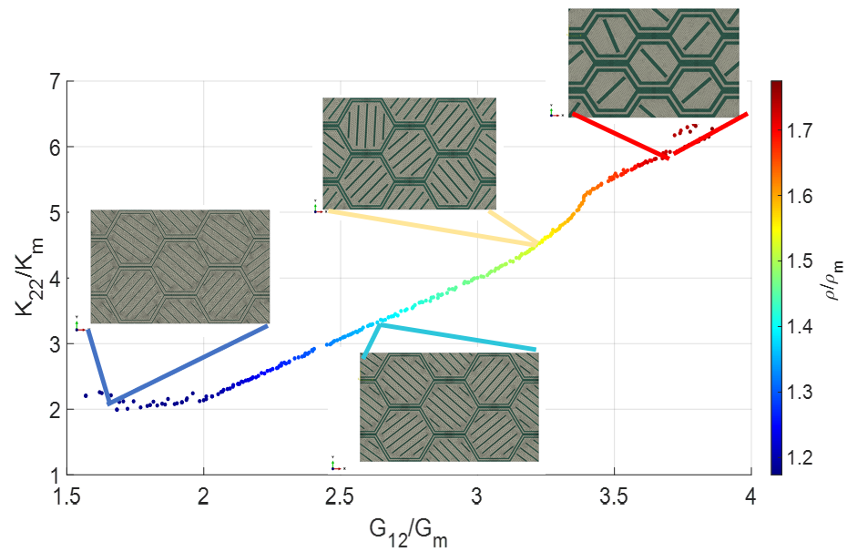

Figure 44. Pareto frontier for optimization for maximum shear modulus, minimum thermal conductivity in 2 direction and minimum density .Representetive microstructures are using alternating diagonal fibers to increase the shear modulus while reducing the thermal conductivity. The results are normalized with respect to the matrix properties $G_{m}=1.75\left[GPa\right],K_{m}=0.12\left[\frac{W}{mK}\right],ρ_{m}=1.4\left[\frac{Tonne}{m^{3}}\right]$

Figure xx show the Pareto frontier result for Minimizing both thermal conductivities in 1 and 2 directions .As expcted, The resulting optimial microstructures are of minimum reinforcement volume fraction ,Thus minimal web size and minimal isolation in the web. In addition, all the Pareto configurations are using the thermal maze concept to decrease the directional conductivity. The different thermal coductivity values of the Pareto are obtained by rotating the thermal maze towards the perpendicular direction.

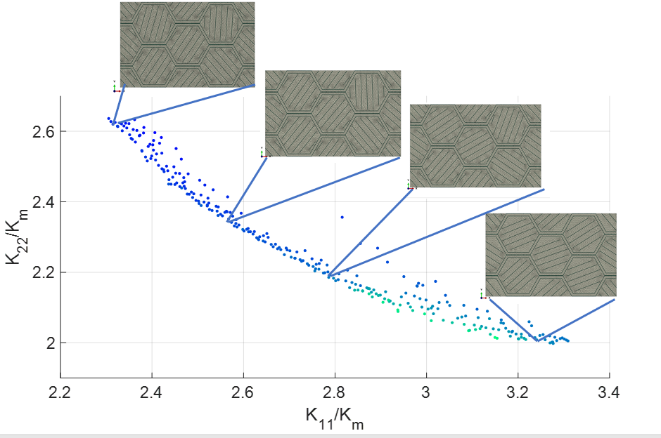

Figure 45. Pareto frontier for optimization for minimum thermal conductivity in 1,2 direction and minimum density .Representetive microstructures are of minimum volume fraction.In addition, using alternating diagonal fibers to reduce the thermal conductivity by forming thermal maze concept. The results are normalized with respect to the matrix properties $,K_{m}=0.12\left[\frac{W}{mK}\right],ρ_{m}=1.4\left[\frac{Tonne}{m^{3}}\right]$

Additional optimization cases was made using 4 objectives . Figure 46 the Pareto results for 2 optimization tasks, both Maximizing 2 Elastic properties while minimizing the thermal conductivity in a single direction and total density. Both cases shows a 3D Pareto surface , the formation of the surface is due to the double maximum requirement – for each effective thermal conductivity value there is a distinct horizontal Pareto frontier , altogether forming the 3D Pareto surface.

Figure 46. Pareto frontier for optimization maximum of 2 elastic modulus costants, minimum thermal conductivity and minimum density .a)max $G_{12},E_{22}$ and min $K_{22}$. b) max $E_{11},E_{22}$ and min $K_{11}$.The double maximum requirement results in a pareto curve for each conductivity value, Thus forming a 3D pareto surface .The results are normalized with respect to the matrix properties

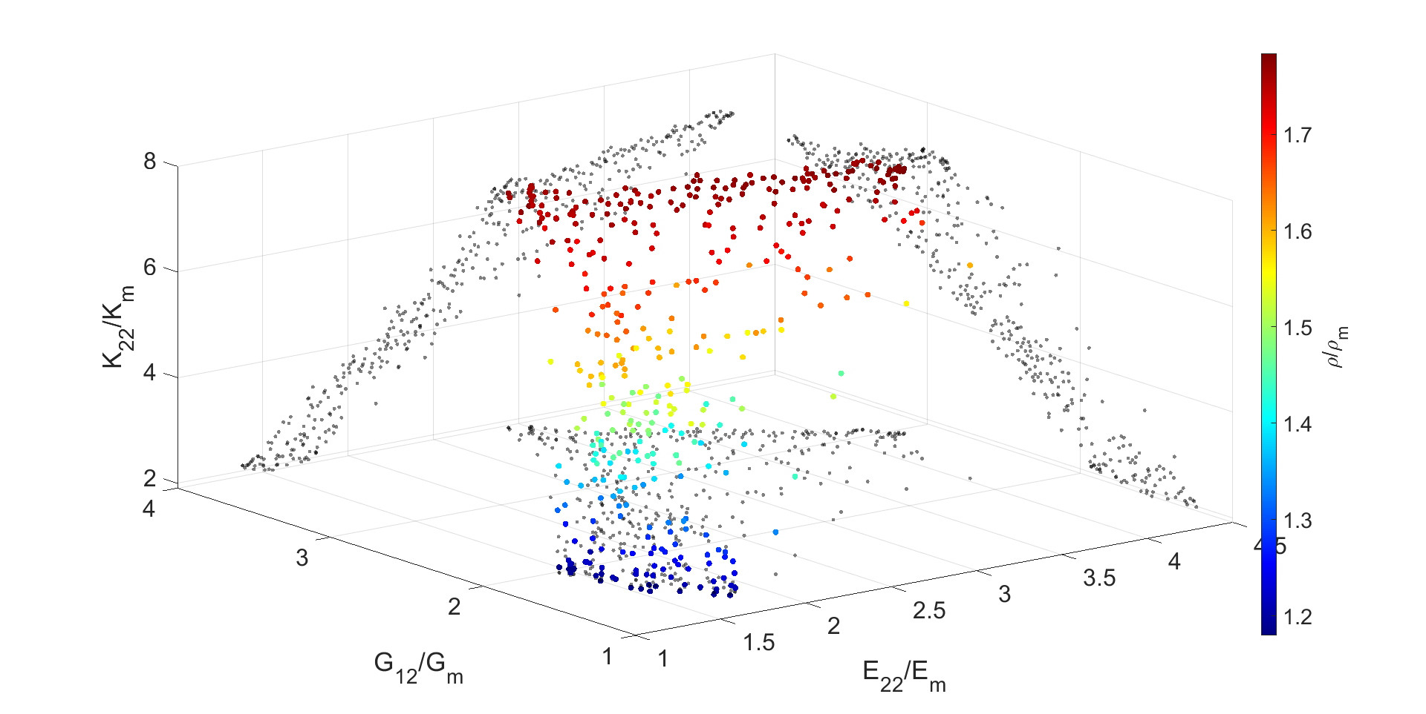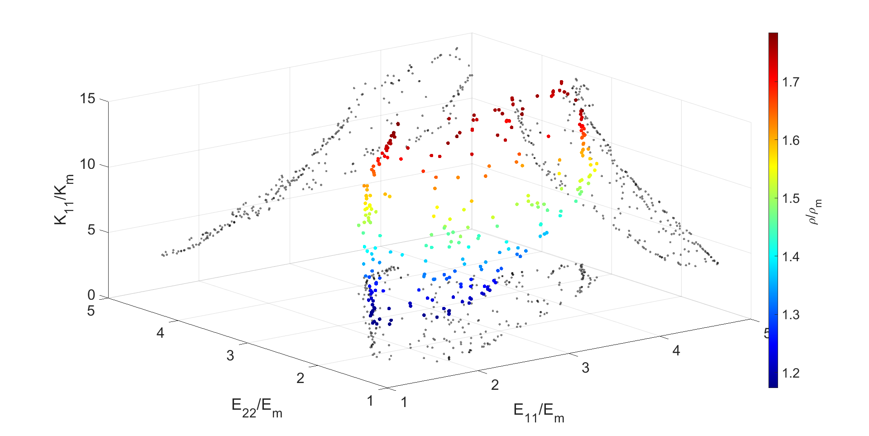

**a)**

**b)**

Figure 47 shows the Pareto results for 2 optimization tasks, both Minimizing 2 thermal conductivity properties while maximizing one elastic property and total density. Both cases shows a 3D Pareto curve which is formed due to the double minimum goal. For each Stiffness value, The double minimum goal generates a localized horizontal Pareto front. The localization of those horizontal fronts appears as individual dots ,Thus forming the 3D curve .

Figure . Pareto frontier for optimization minimum of 2 thermal conductivity constants, maximum elastic moduli and minimum density .a)min $K_{11},K_{22}$ and max $E_{22}$. b) min $K_{11},K_{22}$ and max $G_{12}$.The double minimum requirement results in a localized pareto curve for each conductivity value, Thus forming a 3D pareto curve .The results are normalized with respect to the matrix properties

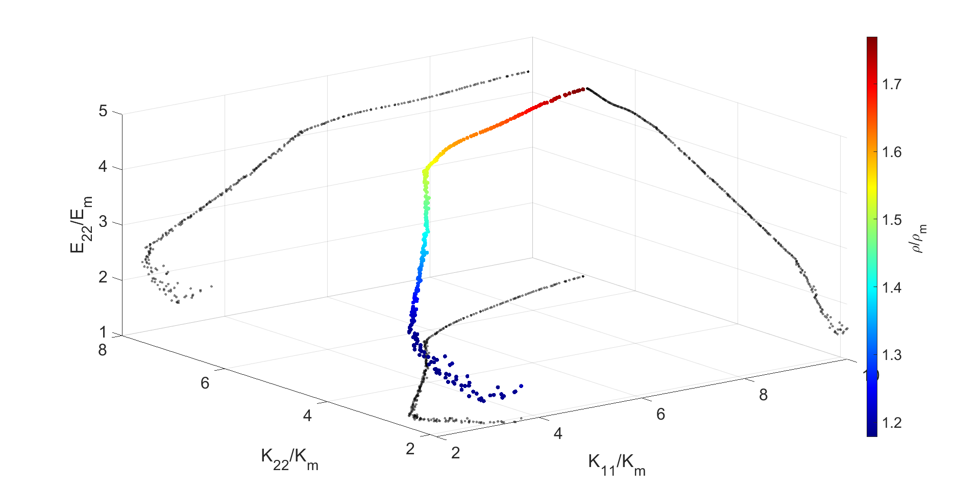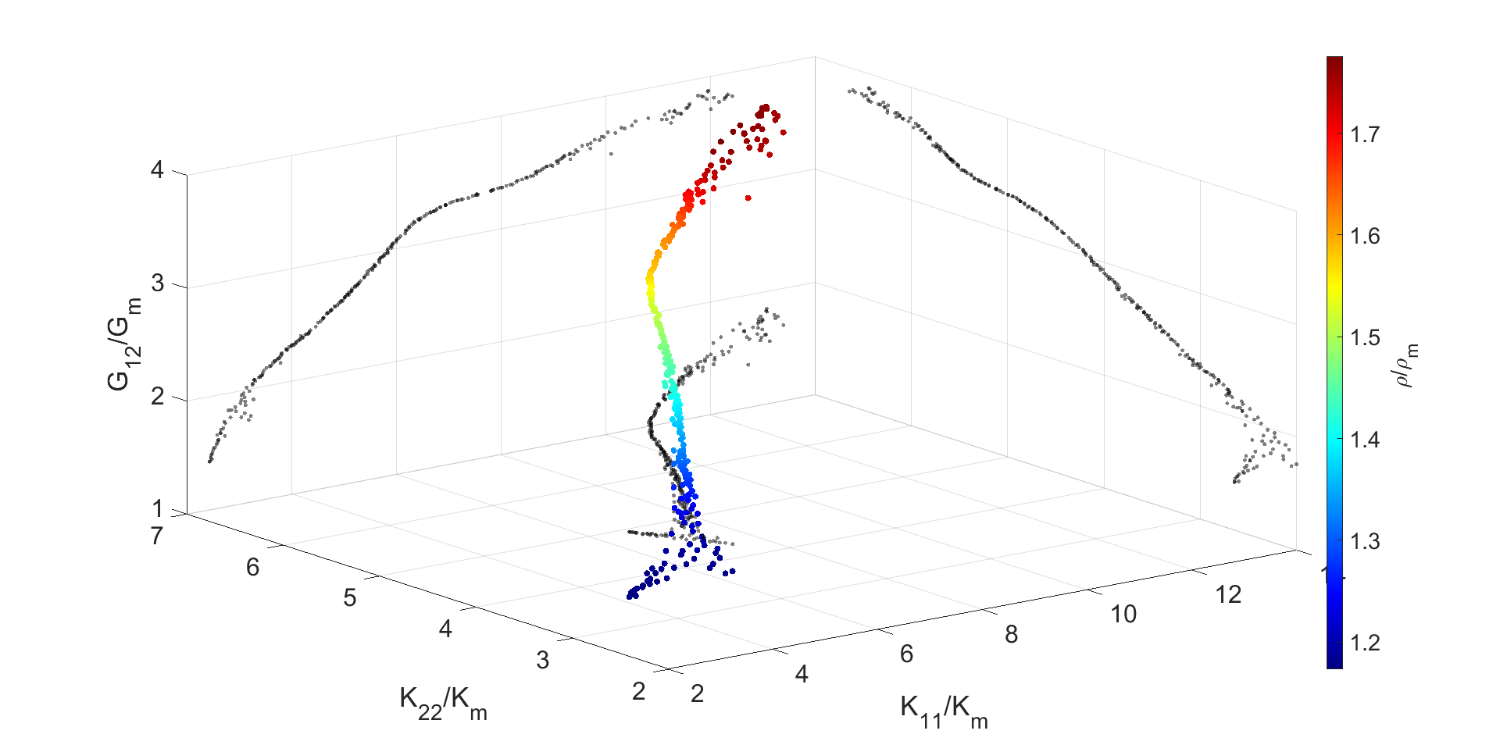

**a)**

**b)**

Comparison to ITPS

How can I compare pareto to a single design?

|  |  |  |  |  |  |
| --- | --- | --- | --- | --- | --- |
| $$ρ$$ | $$E_{1}[GPa]$$ | $$E_{2}[GPa]$$ | $$G_{12}[Gpa]$$ | $$K_{1}[\frac{w}{mK}]$$ | $$K_{2}[\frac{w}{mK}]$$ |
| 2.33 | 27.3 | 7.8 | 2.3 | 1.8 | 0.6 |

|  |  |  |
| --- | --- | --- |
|  |  |  |
|  |  |  |

|  |  |
| --- | --- |
|  |  |
|  |  |

# Discussion:

Say what we did not do- Thermal and mechanical coupling , Constituent materials change in both elastic and thermal properties as function of the temperature .Phases interface modeling   
The model is limited by the initial geometry and parameters limit defined in the model definition phase.

Although the upper and lower limits offer a simple way to inspect and compare the RVE properties with respect to the volume fraction and constituent properties , Hashin -Shtikman bounds are made using the assumption of quazi – isotropic material which is not the case in our project . Voigt and Ruess bounds are widely used for un-isotropic composites but offers a very large properties range. In addition, these boundries deals with properties in a single direction while our project deals with optimizing properties in multiple directions . Some models are (Ref) making an effort to include the properties trade off relation in multiple directions by using a parametric model. The use of such model involve parameter tuning , which makes the resulted limits subjective and highly dependent on the specific parameter selection.

# Summery:

This work presents a quick, accurate and flexible optimization method for multi objective optimization for the design of composite RVE under thermo-mechanical loading with respect to the RVE elastic and thermal conductivity properties. The procedure is based on the combination of numerical homogenization via FEM , Design of Experiments , Surrogate model approximation and multi objective optimization using genetic algorithms.

New micro-structure is proposed based on an metallic honeycomb structure filled with lightweight resin and inclined reinforcing fibers. The periodic composite RVE meshed parametric model is created using Python scripting with integration of ABAQUS software environment. The 10 dimensional design space is spanned using Latin Hyper Cube Sampling for maximal space filling efficiency. Geometric parameter based database is used as input for the periodic thermal and mechanical simulation procedure to create a geometry parameters-thermo-mechanical properties relation.Two surrogate models are trained and compared for the prediction of the geometry input parameters to the output thermo-mechanical properties. Due to its high learning speed and the ability to predict multiple variables at once, A Shallow Neural network is selected as the preferred lightweight surrogate model.The selected model is then used for goal based optimization procedure using single objective function which is found to be inefficient due to the need to fine tune multiple parameters in the objective function for each single objective. Multi objective optimization robust process is made using NSGA-II algorithm implemented in MATLAB. The Pareto frontiers presented in as the result of the different optimization proccesss shows a variaty of optimal design points with respect to the designers goals and limitations .

# References:

[1] H. W. Jones, “The Recent Large Reduction in Space Launch Cost,” 2018.

[2] L. Zhu, N. Li, and P. R. N. Childs, “Light-weighting in aerospace component and system design,” *Propulsion and Power Research*, vol. 7, no. 2, pp. 103–119, Jun. 2018, doi: 10.1016/J.JPPR.2018.04.001.

[3] P. F. Thurier, G. A. Lesieutre, M. I. Frecker, and J. H. Adair, “A two-material topology optimization method for structures under steady thermo-mechanical loading:,” *https://doi.org/10.1177/1045389X19844029*, vol. 30, no. 11, pp. 1717–1726, Apr. 2019, doi: 10.1177/1045389X19844029.

[4] Q. Xu, S. Li, and Y. Meng, “Optimization and Re-Design of Integrated Thermal Protection Systems Considering Thermo-Mechanical Performance,” *Applied Sciences 2021, Vol. 11, Page 6916*, vol. 11, no. 15, p. 6916, Jul. 2021, doi: 10.3390/APP11156916.

[5] X. Fang *et al.*, “Optimized design of sandwich panels for integral thermal protection systems,” *Structural and Multidisciplinary Optimization*, vol. 55, no. 1, pp. 13–23, Jan. 2017, doi: 10.1007/S00158-016-1560-9.

[6] C. Pichler, G. Metzler, C. Niederegger, and R. Lackner, “Thermo-mechanical optimization of porous building materials based on micromechanical concepts: Application to load-carrying insulation materials,” *Composites Part B: Engineering*, vol. 43, no. 3, pp. 1015–1023, Apr. 2012, doi: 10.1016/J.COMPOSITESB.2011.09.013.

[7] “(2) Design of masonry blocks with enhanced thermomechanical performances by topology optimization | Alberto Taliercio - Academia.edu.” https://www.academia.edu/19269755/Design_of_masonry_blocks_with_enhanced_thermomechanical_performances_by_topology_optimization (accessed Apr. 03, 2022).

[8] K. Wei, K. Wang, X. Cheng, Y. Peng, M. Li, and X. Yang, “Structural and thermal analysis of integrated thermal protection systems with C/SiC composite cellular core sandwich panels,” *Applied Thermal Engineering*, vol. 131, pp. 209–220, Feb. 2018, doi: 10.1016/J.APPLTHERMALENG.2017.12.009.

[9] O. Sigmund, “A new class of extremal composites,” *Journal of the Mechanics and Physics of Solids*, vol. 48, no. 2, pp. 397–428, Feb. 2000, doi: 10.1016/S0022-5096(99)00034-4.

[10] M. Bruggi and C. Cinquini, “Topology optimization for thermal insulation: An application to building engineering,” *Engineering Optimization*, vol. 43, no. 11, pp. 1223–1242, Nov. 2011, doi: 10.1080/0305215X.2010.550284.

[11] V. J. Challis, A. P. Roberts, and A. H. Wilkins, “Design of three dimensional isotropic microstructures for maximized stiffness and conductivity,” *International Journal of Solids and Structures*, vol. 45, no. 14–15, pp. 4130–4146, Jul. 2008, doi: 10.1016/J.IJSOLSTR.2008.02.025.

[12] B. Xu, X. Huang, S. W. Zhou, and Y. M. Xie, “Concurrent topological design of composite thermoelastic macrostructure and microstructure with multi-phase material for maximum stiffness,” *Composite Structures*, vol. C, no. 150, pp. 84–102, Aug. 2016, doi: 10.1016/J.COMPSTRUCT.2016.04.038.

[13] O. Sigmund, “Materials with prescribed constitutive parameters: An inverse homogenization problem,” *International Journal of Solids and Structures*, vol. 31, no. 17, pp. 2313–2329, Sep. 1994, doi: 10.1016/0020-7683(94)90154-6.

[14] I. M. Daniel and Ori. Ishai, *Engineering mechanics of composite materials*. Oxford University Press, 2006.

[15] E. J. Barbero, “Introduction to Composite Materials Design,” *Introduction to Composite Materials Design*, Jul. 2010, doi: 10.1201/9781439894132.

[16] D. E. Glass, “Ceramic matrix composite (CMC) thermal protection systems (TPS) and hot structures for hypersonic vehicles,” *15th AIAA International Space Planes and Hypersonic Systems and Technologies Conference*, 2008, doi: 10.2514/6.2008-2682.

[17] T. J. Wooster, S. Abrol, J. M. Hey, and D. R. MacFarlane, “Thermal, mechanical, and conductivity properties of cyanate ester composites,” *Composites Part A: Applied Science and Manufacturing*, vol. 35, no. 1, pp. 75–82, Jan. 2004, doi: 10.1016/J.COMPOSITESA.2003.09.002.

[18] D. Wilson, “Recent advances in polyimide composites:,” *http://dx.doi.org/10.1088/0954-0083/5/2/001*, vol. 5, no. 2, pp. 77–95, Nov. 2016, doi: 10.1088/0954-0083/5/2/001.

[19] S. Chou, H. C. Chen, and C. C. Wu, “BMI resin composites reinforced with 3D carbon-fibre fabrics,” *Composites Science and Technology*, vol. 43, no. 2, pp. 117–128, Jan. 1992, doi: 10.1016/0266-3538(92)90002-K.

[20] T. M. Keller, “Phthalonitrile-based high temperature resin,” *Journal of Polymer Science Part A: Polymer Chemistry*, vol. 26, no. 12, pp. 3199–3212, Nov. 1988, doi: 10.1002/POLA.1988.080261207.

[21] “Automotive applications for advanced composite materials (Conference) | OSTI.GOV.” https://www.osti.gov/biblio/6901139 (accessed Apr. 03, 2022).

[22] R. Hill, “Elastic properties of reinforced solids: Some theoretical principles,” *Journal of the Mechanics and Physics of Solids*, vol. 11, no. 5, pp. 357–372, Sep. 1963, doi: 10.1016/0022-5096(63)90036-X.

[23] W. Wu, J. Owino, A. Al-Ostaz, and L. Cai, “Applying Periodic Boundary Conditions in Finite Element Analysis”.

[24] S. L. Omairey, P. D. Dunning, and S. Sriramula, “Development of an ABAQUS plugin tool for periodic RVE homogenisation,” *Engineering with Computers*, vol. 35, no. 2, pp. 567–577, Apr. 2019, doi: 10.1007/S00366-018-0616-4/TABLES/3.

[25] W. Ogierman, G. K.-J. of achievements in materials and, and undefined 2013‏, “Mean field homogenization in multi-scale modelling of composite materials‏,” *delibra.bg.polsl.pl‏*, Accessed: Apr. 05, 2022. [Online]. Available: http://delibra.bg.polsl.pl/Content/32154/BCPS_35623_-_Mean-field-homogeniz_0000.pdf

[26] R. Penta and A. Gerisch, “An introduction to asymptotic homogenization,” *Lecture Notes in Computational Science and Engineering*, vol. 122, pp. 1–26, 2017, doi: 10.1007/978-3-319-73371-5_1/FIGURES/5.

[27] Z. Hashin and S. Shtrikman, “A variational approach to the theory of the elastic behaviour of multiphase materials,” *Journal of the Mechanics and Physics of Solids*, vol. 11, no. 2, pp. 127–140, Mar. 1963, doi: 10.1016/0022-5096(63)90060-7.

[28] G. W. Milton and R. v. Kohn, “Variational bounds on the effective moduli of anisotropic composites,” *Journal of the Mechanics and Physics of Solids*, vol. 36, no. 6, pp. 597–629, Jan. 1988, doi: 10.1016/0022-5096(88)90001-4.

[29] J. R. Willis, “Bounds and self-consistent estimates for the overall properties of anisotropic composites,” *Journal of the Mechanics and Physics of Solids*, vol. 25, no. 3, pp. 185–202, Jun. 1977, doi: 10.1016/0022-5096(77)90022-9.

[30] J. K. Carson, S. J. Lovatt, D. J. Tanner, and A. C. Cleland, “Thermal conductivity bounds for isotropic, porous materials,” *International Journal of Heat and Mass Transfer*, vol. 48, no. 11, pp. 2150–2158, May 2005, doi: 10.1016/J.IJHEATMASSTRANSFER.2004.12.032.

[31] K. Priddy and P. Keller, *Artificial neural networks: an introduction‏*. Accessed: Apr. 05, 2022. [Online]. Available: https://www.google.com/books?hl=iw&lr=&id=BrnHR7esWmkC&oi=fnd&pg=PP13&ots=Uz2CTm4DNT&sig=WRRQdO8sUCwJHr8Ad7wtfcWMsmA

[32] Z. Yang *et al.*, “Deep learning approaches for mining structure-property linkages in high contrast composites from simulation datasets,” *Computational Materials Science*, vol. 151, pp. 278–287, Aug. 2018, doi: 10.1016/J.COMMATSCI.2018.05.014.

[33] S. Kumar, S. Tan, L. Zheng, and D. M. Kochmann, “Inverse-designed spinodoid metamaterials,” *npj Computational Materials 2020 6:1*, vol. 6, no. 1, pp. 1–10, Jun. 2020, doi: 10.1038/s41524-020-0341-6.

[34] Z. L. Wang and Y. Adachi, “Property prediction and properties-to-microstructure inverse analysis of steels by a machine-learning approach,” *Materials Science and Engineering A*, vol. 744, pp. 661–670, Jan. 2019, doi: 10.1016/J.MSEA.2018.12.049.

[35] A. Chowdhury, E. Kautz, B. Yener, and D. Lewis, “Image driven machine learning methods for microstructure recognition,” *Computational Materials Science*, vol. 123, pp. 176–187, Oct. 2016, doi: 10.1016/J.COMMATSCI.2016.05.034.

[36] Y. Sun, I. Hanhan, M. D. Sangid, and G. Lin, “Predicting Mechanical Properties from Microstructure Images in Fiber-reinforced Polymers using Convolutional Neural Networks”.

[37] C. E. Rasmussen, “Gaussian Processes in Machine Learning,” *Lecture Notes in Computer Science (including subseries Lecture Notes in Artificial Intelligence and Lecture Notes in Bioinformatics)*, vol. 3176, pp. 63–71, 2004, doi: 10.1007/978-3-540-28650-9_4.

[38] L. Wang, S. Tao, P. Zhu, and W. Chen, “Data-Driven Topology Optimization with Multiclass Microstructures using Latent Variable Gaussian Process,” *Journal of Mechanical Design, Transactions of the ASME*, vol. 143, no. 3, Jun. 2020, doi: 10.48550/arxiv.2006.15273.

[39] A. Venkatraman, D. Montes de Oca Zapiain, H. Lim, and S. R. Kalidindi, “Texture-sensitive prediction of micro-spring performance using Gaussian process models calibrated to finite element simulations,” *Materials & Design*, vol. 197, p. 109198, Jan. 2021, doi: 10.1016/J.MATDES.2020.109198.

[40] J. Wang, “An Intuitive Tutorial to Gaussian Processes Regression,” Sep. 2020, doi: 10.48550/arxiv.2009.10862.

[41] N. v. Queipo, R. T. Haftka, W. Shyy, T. Goel, R. Vaidyanathan, and P. Kevin Tucker, “Surrogate-based analysis and optimization,” *Progress in Aerospace Sciences*, vol. 41, no. 1, pp. 1–28, 2005, doi: 10.1016/J.PAEROSCI.2005.02.001.

[42] M. J. Anderson and P. J. Whitcomb, “Design of Experiments,” pp. 1–22, 1978, doi: 10.1002/0471238961.0405190908010814.A01.PUB3.

[43] W. L. Loh, “On Latin hypercube sampling,” *https://doi.org/10.1214/aos/1069362310*, vol. 24, no. 5, pp. 2058–2080, Oct. 1996, doi: 10.1214/AOS/1069362310.

[44] G. Venter, “Review of Optimization Techniques,” *Encyclopedia of Aerospace Engineering*, Dec. 2010, doi: 10.1002/9780470686652.EAE495.

[45] A. Slowik and H. Kwasnicka, “Evolutionary algorithms and their applications to engineering problems,” *Neural Computing and Applications*, vol. 32, no. 16, pp. 12363–12379, Aug. 2020, doi: 10.1007/S00521-020-04832-8/TABLES/4.

[46] K. Deb, A. Pratap, S. Agarwal, and T. Meyarivan, “A fast and elitist multiobjective genetic algorithm: NSGA-II,” *IEEE Transactions on Evolutionary Computation*, vol. 6, no. 2, pp. 182–197, Apr. 2002, doi: 10.1109/4235.996017.

[47] S. Kumar and E. Povoden-Karadeniz, “Plastic Deformation Behavior in Steels during Metal Forming Processes: A Review,” *Plastic Deformation in Materials [Working Title]*, May 2021, doi: 10.5772/INTECHOPEN.97607.

[48] “Abaqus CAE - SIMULATM by Dassault Systèmes®.” https://www.3ds.com/products-services/simulia/products/abaqus/abaquscae/ (accessed Apr. 11, 2022).

[49] C. Geuzaine and J.-F. Remacle, “Gmsh: a three-dimensional finite element mesh generator with built-in pre-and post-processing facilities,” *INTERNATIONAL JOURNAL FOR NUMERICAL METHODS IN ENGINEERING Int. J. Numer. Meth. Engng*, vol. 0, pp. 1–24, 2009.

[50] M. Ashby, “Materials selection in mechanical design: Fourth edition,” *Materials Selection in Mechanical Design: Fourth Edition*, vol. 9780080952239, pp. 1–646, Sep. 2010.

[51] S. L. Omairey, P. D. Dunning, and S. Sriramula, “Development of an ABAQUS plugin tool for periodic RVE homogenisation,” *Engineering with Computers*, vol. 35, no. 2, pp. 567–577, Apr. 2019, doi: 10.1007/S00366-018-0616-4/TABLES/3.

[52] “MATLAB - MathWorks - MATLAB & Simulink.” https://www.mathworks.com/products/matlab.html (accessed May 17, 2022).

[53] M. Kursa, K. Kowalczyk-Gajewska, and H. Petryk, “MULTI-OBJECTIVE OPTIMIZATION OF EFFECTIVE THERMO-MECHANICAL PROPERTIES OF METAL-CERAMIC COMPOSITES‏,” *2012‏*, Accessed: Jul. 06, 2022. [Online]. Available: http://oldwww.ippt.pan.pl/Repository/o1756.pdf